

**INDIVIDUAL ASSIGNMENT**

**TECHNOLOGY PARK MALAYSIA**

**CT010-3-1-PYP**

**PYTHON PROGRAMMING**

**APD1F2106/APU1F2016 – CE/ME/TE/PE/EEE/CS/CS(CYB)/SE/IS/IT/CS(DF)/MMT/CGD**

**HAND OUT DATE: 19TH JULY 2021**

**HAND IN DATE: 17TH SEPTEMBER 2021**

**WEIGHTAGE: 100%**

**Name : Soh Wei Zheng**

**TP Number: TP063631**

**Table of Contents**

**Introduction and Assumption-----------------------------------------------------------------------------------3**

**Design of the Program--------------------------------------------------------------------------------------------6**

**Pseudocode-------------------------------------------------------------------------------------------------**6

**Flowchart--------------------------------------------------------------------------------------------------**17

**Program Source Code And Explanation---------------------------------------------------------------------64**

**Screenshots Of Sample Input/Output And Explanation--------------------------------------------------75**

**Conclusion----------------------------------------------------------------------------------------------------------99**

**Introduction And Assumptions**

“COVID-19 Vaccination Record Management System” is a program which is developed by me. The program provides 4 functions that can improve the vaccination system. There are 4 functions in the program including the first function “New Patient Registration”, the second function “Vaccine Administration”, the third function “Search Patient Record and Vaccination Status”, and the fourth function “Statistical Information on Patients Vaccinated”.

Once the program is running, the first prompt leap to the eyes is requiring user to press ‘Enter’ to show the main menu. After the user presses it, it will show the menu.

New Patient Registration provides users who haven’t registered for any vaccination or new user to register for their ‘patient ID’. Vaccination Administration allows users to register for their vaccination for dose 1 and dose 2. Search Patient Record and Vaccination Status provides a search engine for checking patient’s status purpose. Statistical Information on Patients Vaccinated makes a sum of half-vaccinated patients and fully-vaccinated patients at each vaccination centres.

New Patient Registration will prompt user to choose a vaccination centre. After that, users have to input their details which will be stored in “patient.txt” file such as their names, contact numbers, and ages. Besides, their chosen vaccination centres, vaccine codes, and the status of dose 1 and dose2 will be stored in “patient.txt”. There is no vaccine for users who is below 12 years old and they will be rejected.

Vaccination Administration provides users to register for their dose 1. After enter vaccination administration, the program requires patients to insert their user ID. The program will check if they have registered for dose 1 and dose 2, and allow patients to register for vaccination. After registering dose 1, patient will be informed that how many weeks should be waited for them and patient who have completed both doses will be informed. Users who have registered for dose 1 and dose 2 will be stored in “vaccination.txt” file. The file will be updated every times after someone registered for their vaccination.

Search Patient Record and Vaccination Status is a checking system. Users can check their status by searching their IDs. If their IDs were not found, they will be informed; If their ID’s are found, the program will show their names, vaccine codes, vaccine status.

Statistical Information on Patients Vaccinated calculates the numbers of users who waiting for dose 2 and the numbers of users who have completed their vaccination at vaccination centre 1; and calculates the numbers of users who waiting for dose 2 and the numbers of users who have completed their vaccination at vaccination centre 2.

The program can be stopped or exit by using ‘x’ at the main menu.

**Design Of The Program**

**Pseudocode**

**Function writingTo()**

-Function writingListToPatient()

-Function writingListToVaccination()

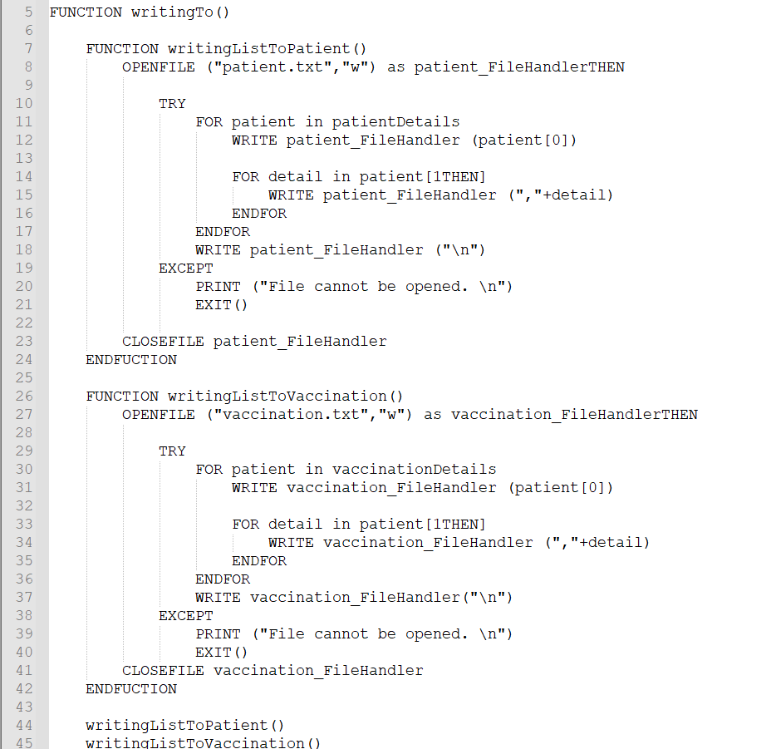

**Function convert()**

-Function listPatientDetails()

-Function listVaccinationDetails()

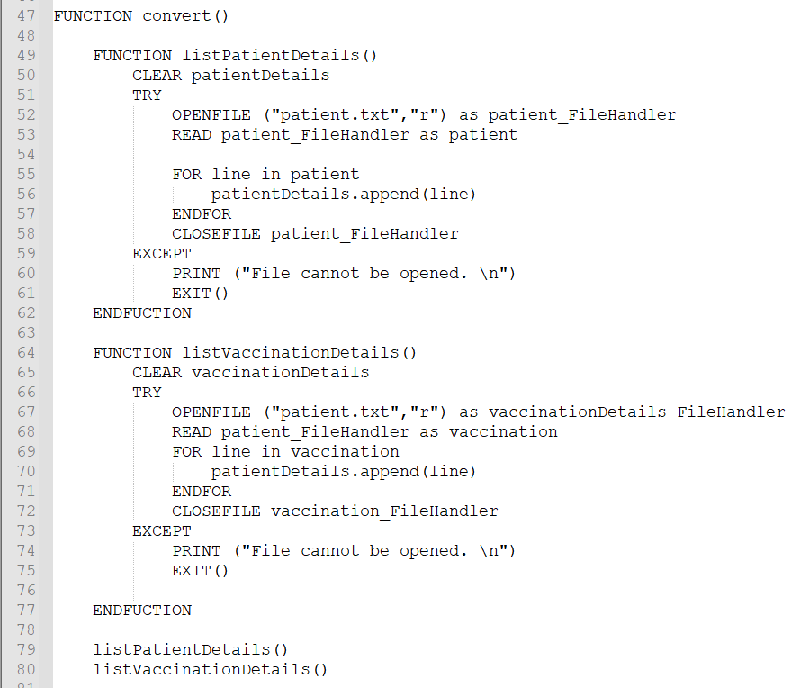

**Function newPatientRegistration()**

- Function vaccineCode(patientAge)

- Function patientID()

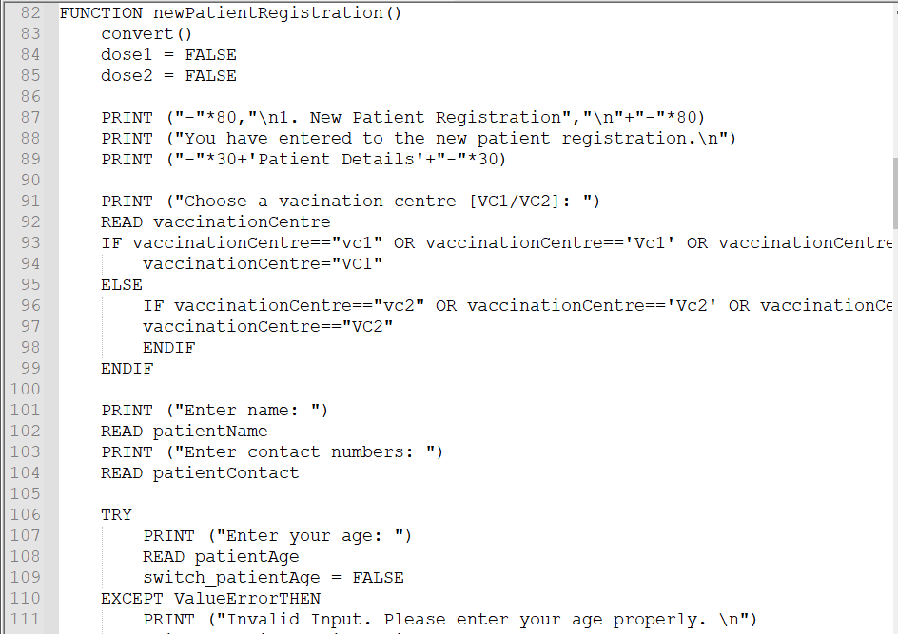

-Function vaccineCode(patientAge)

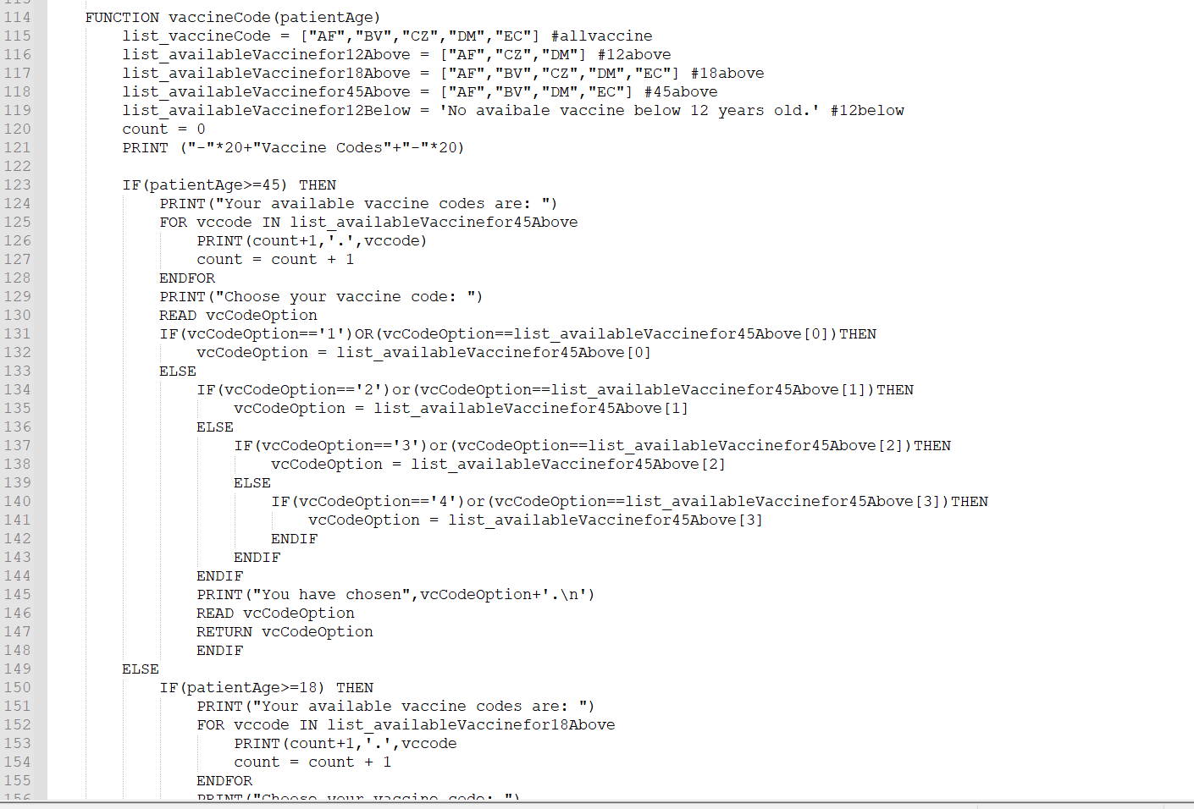

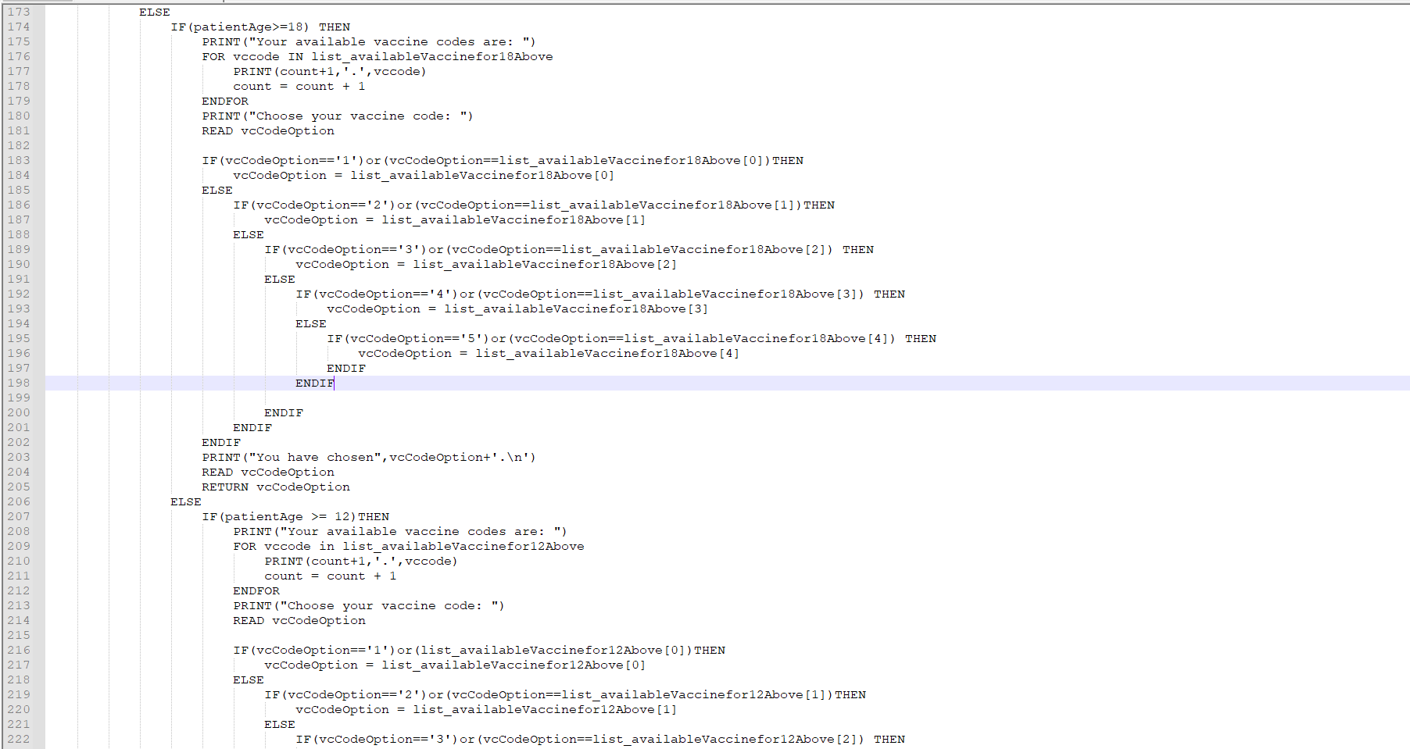

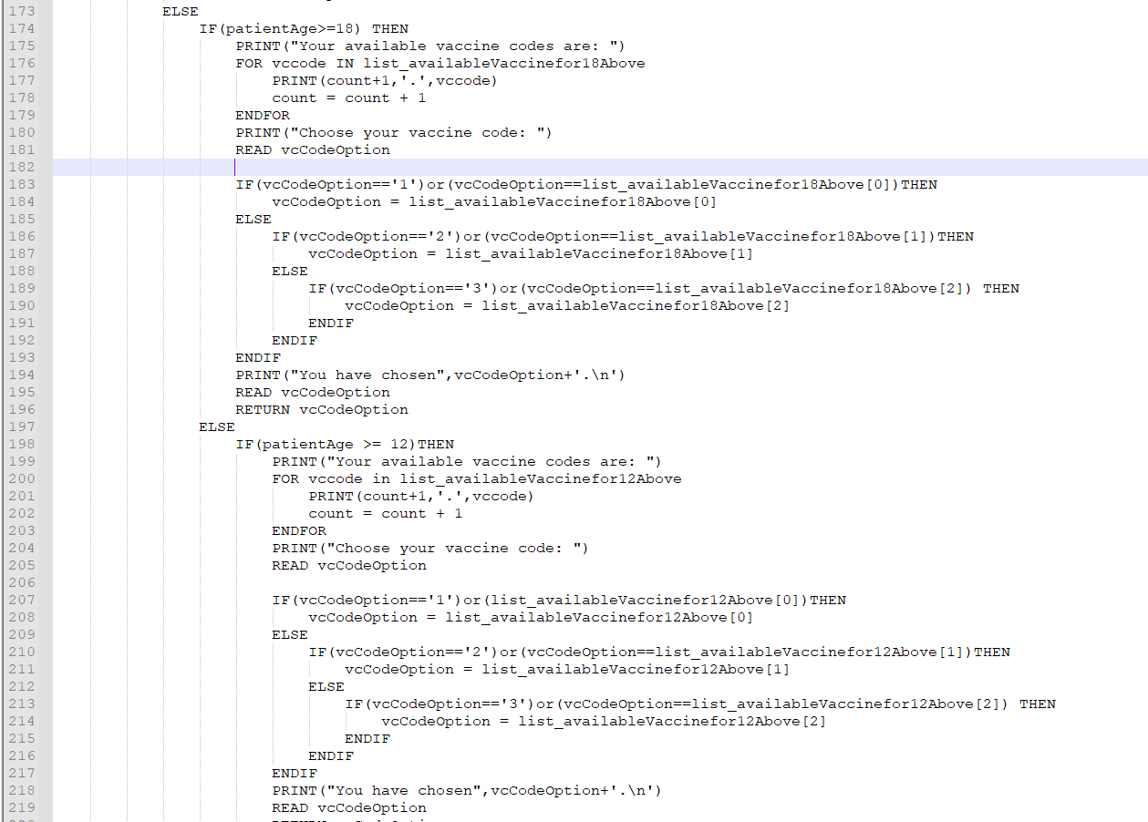

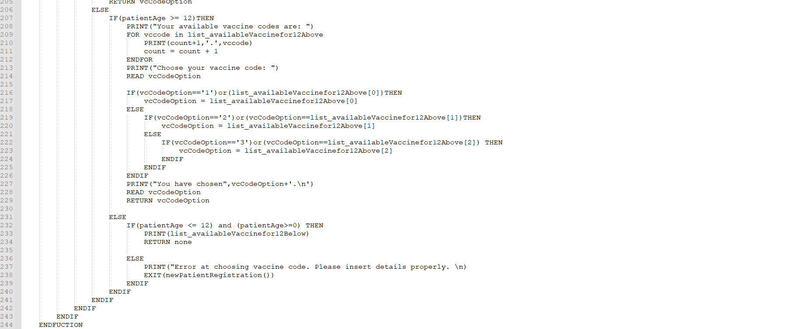

-Function patientID()

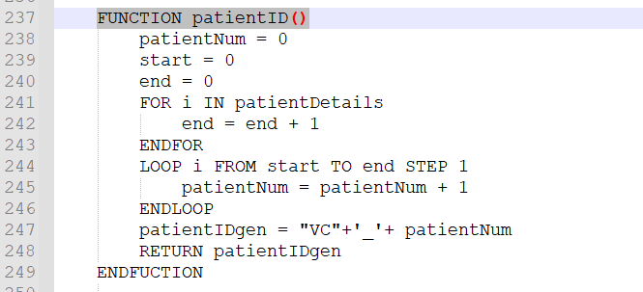

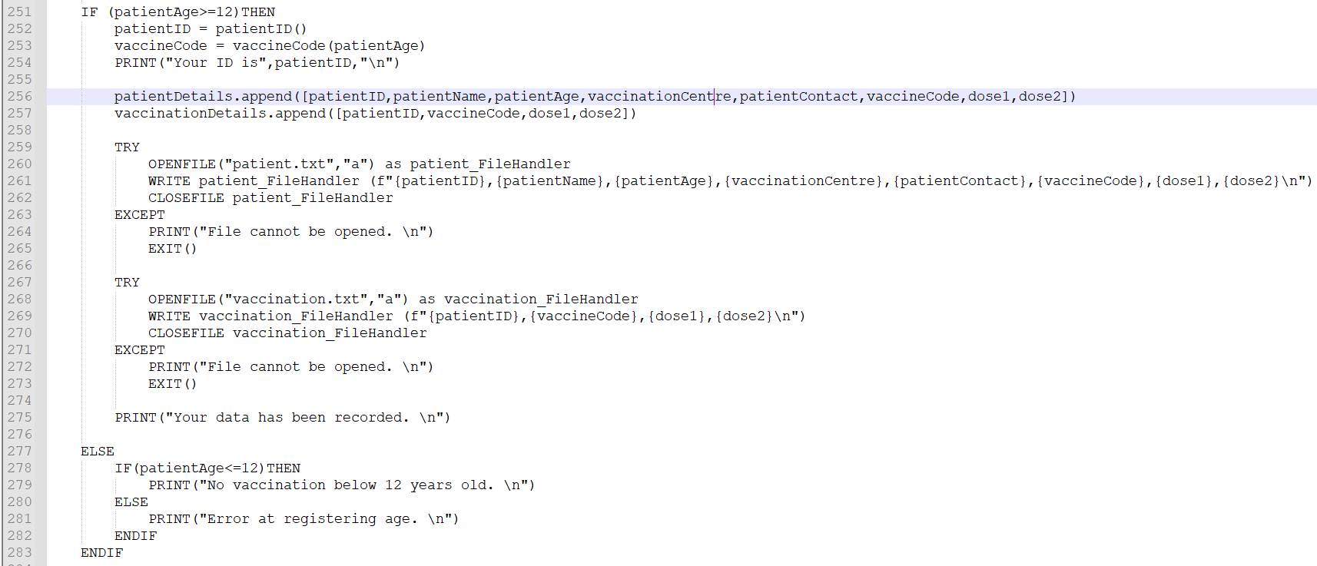

**Function vaccineAdministration()**

-Function vacWeekDisplay()

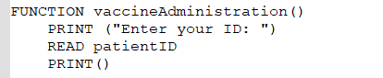

-Function vacWeekDisplay()

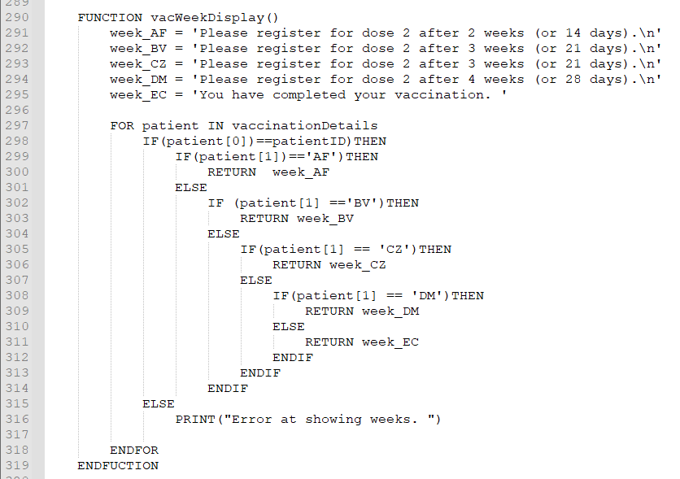

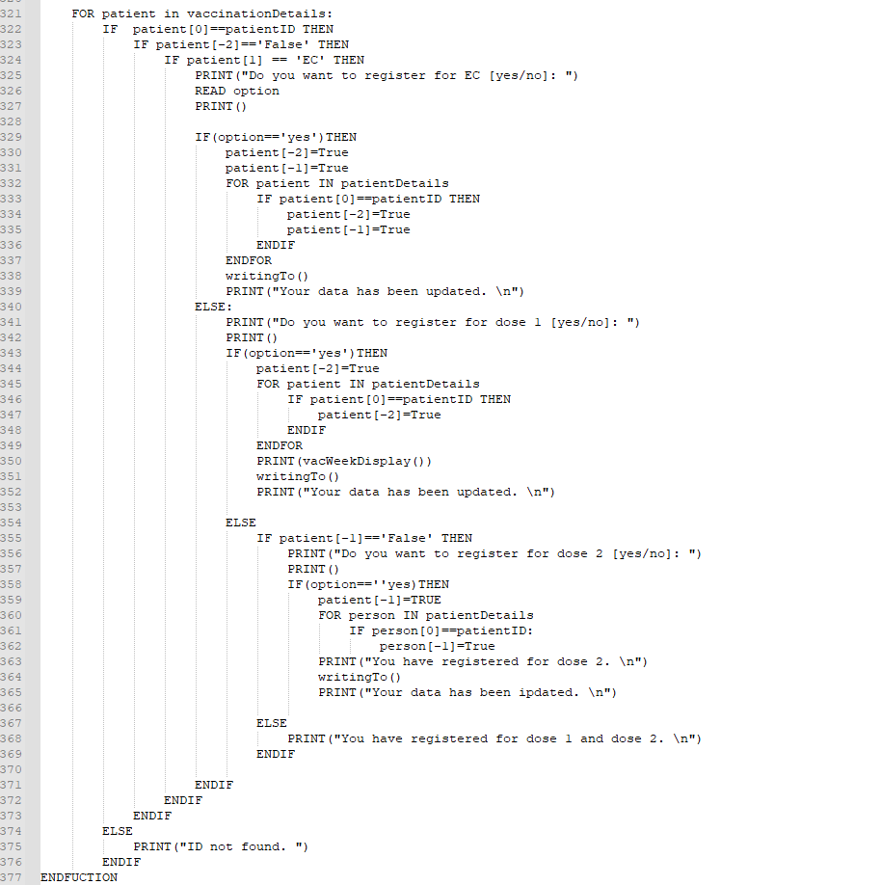

**Function searchPatientRecordAndVaccinationStatus()**

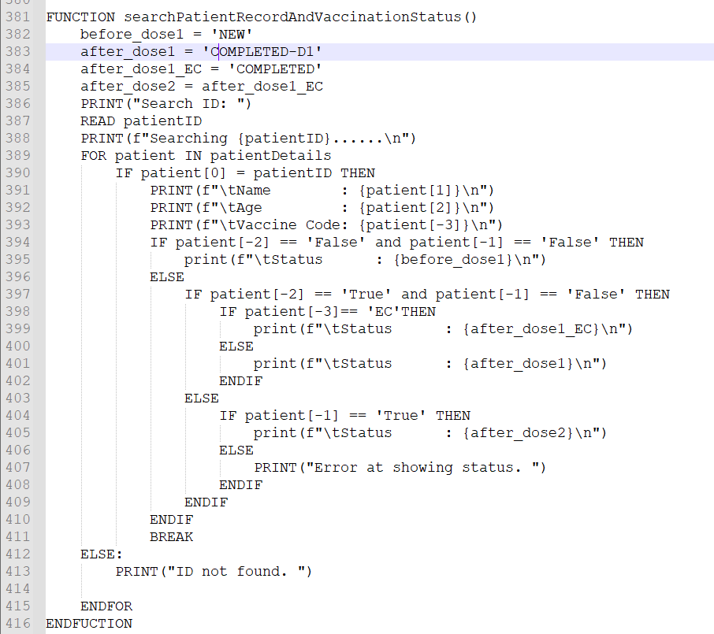

**Function statisticalInformationOnPatientsVaccinated()**

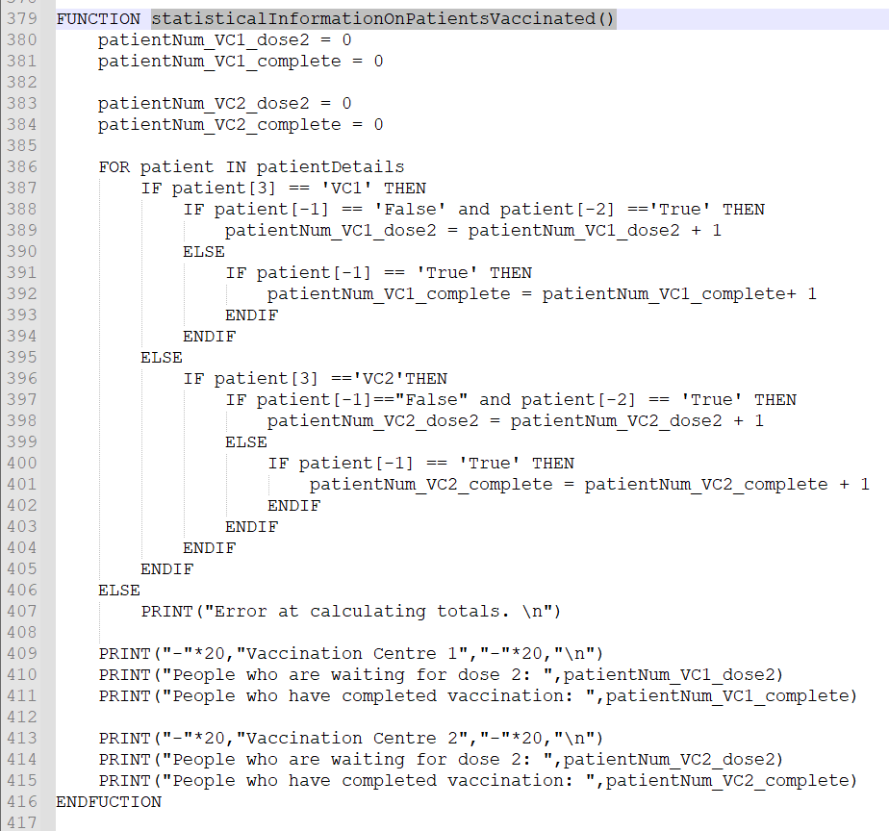

**Function menu()**

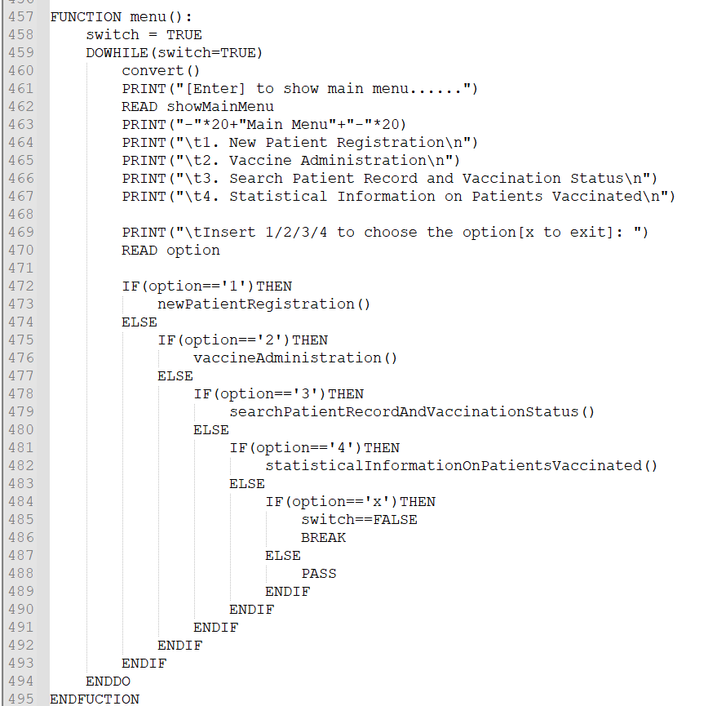

**Main Program**

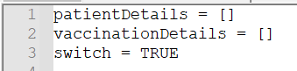



**Flowchart**

**writingListToPatient()**

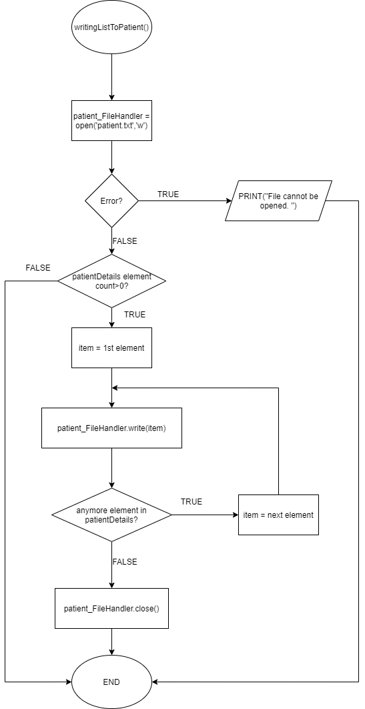

**writingToVaccination()**

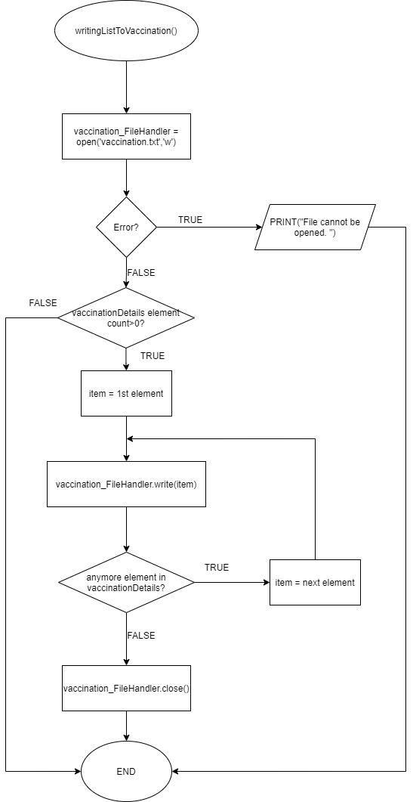

**writingTo()**

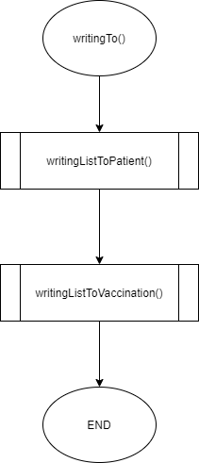

**listPatientDetails()**

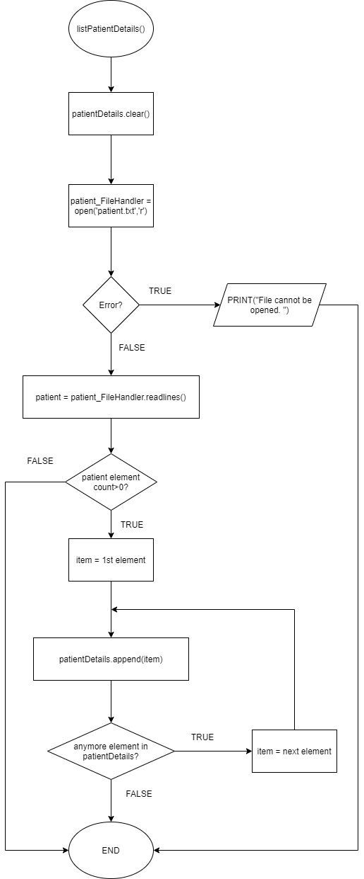

**listVaccinationDetails()**

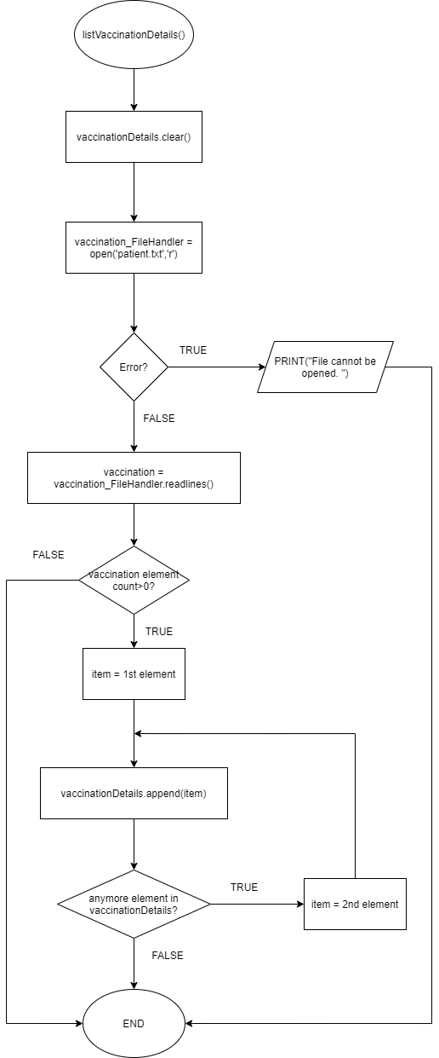

**convert()**

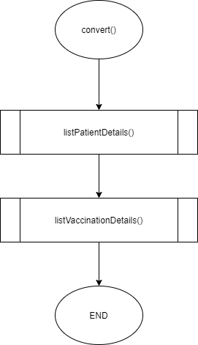

**patientID()**

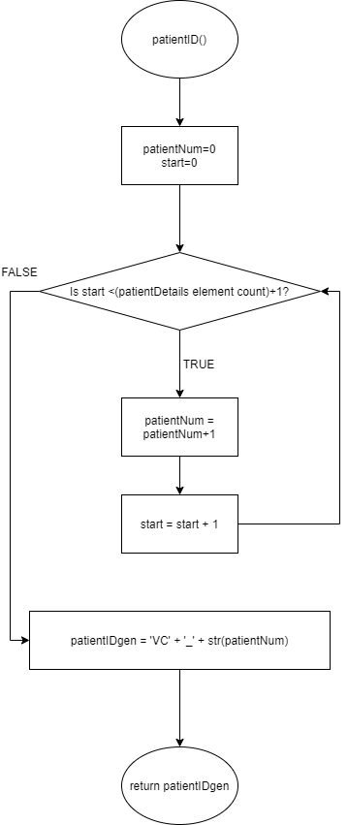

**vaccineCode(patientAge)**

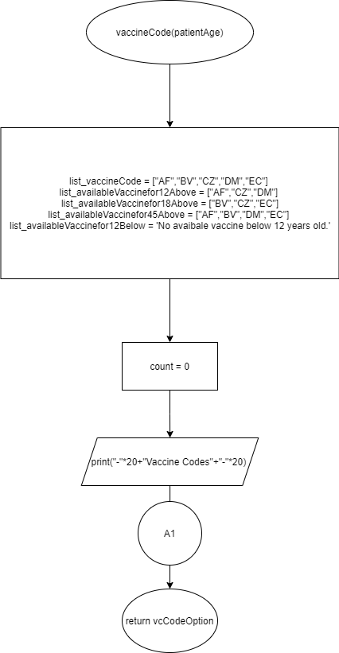

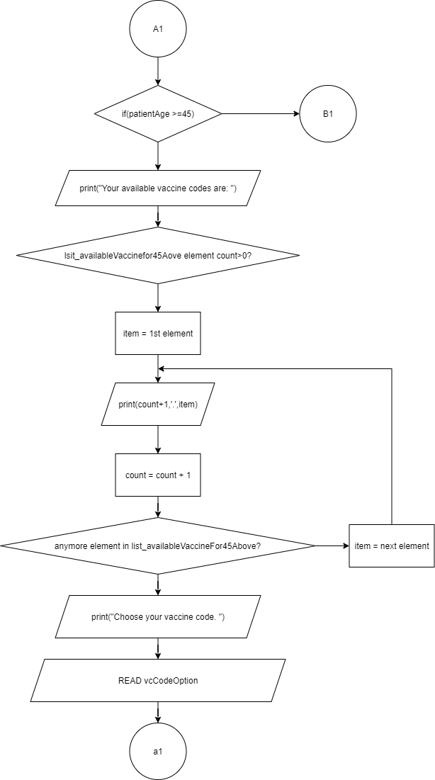

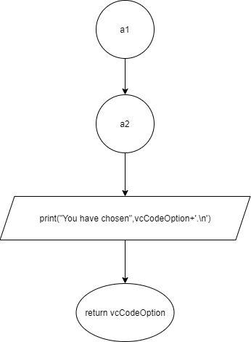

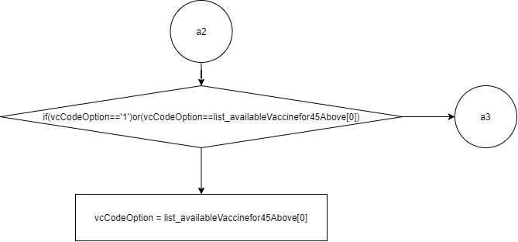

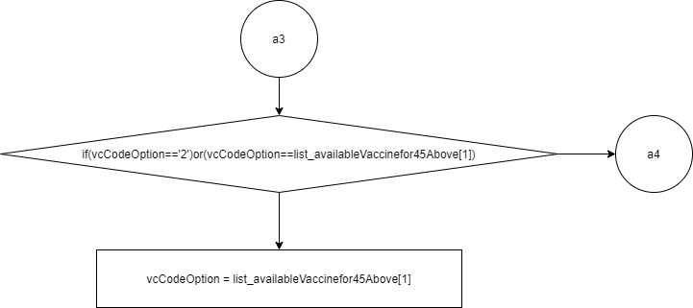

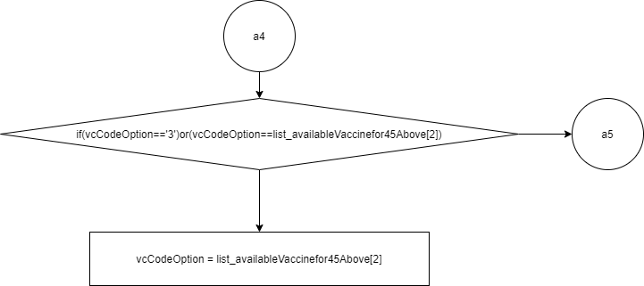

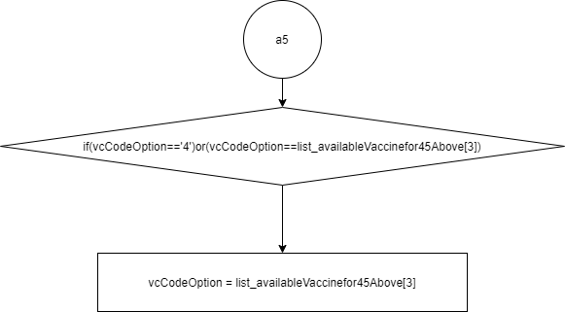

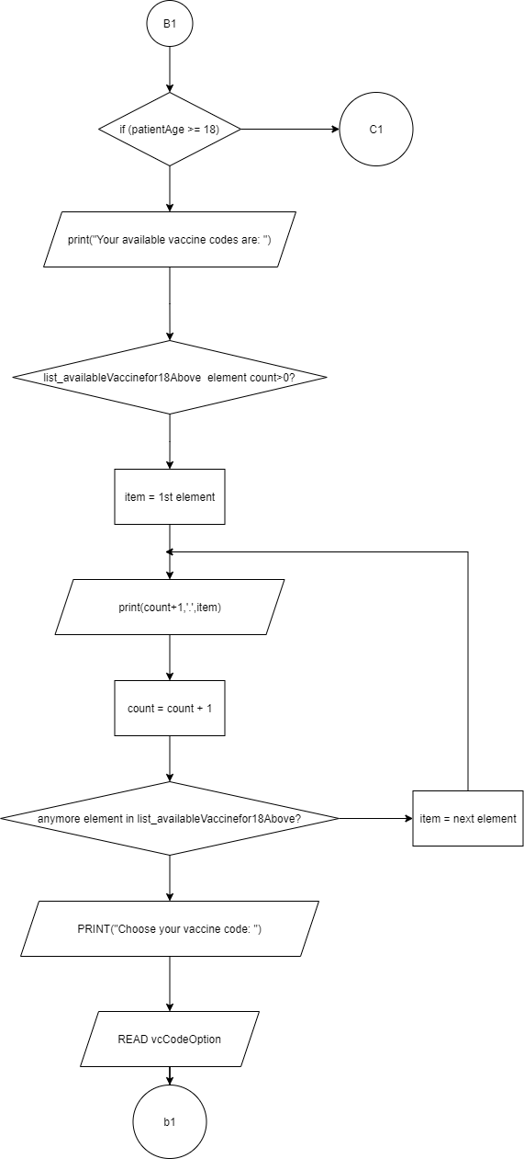

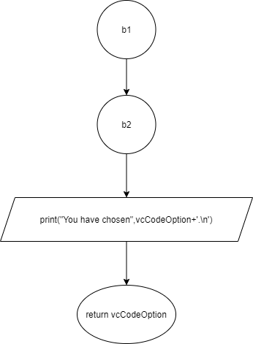

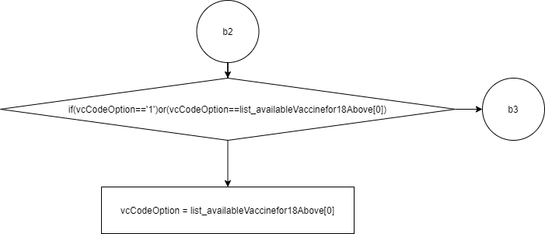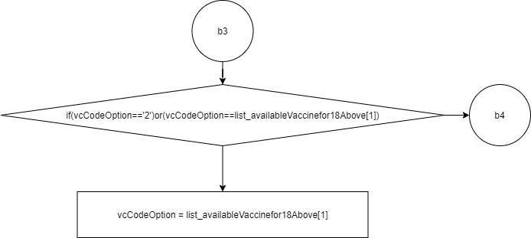

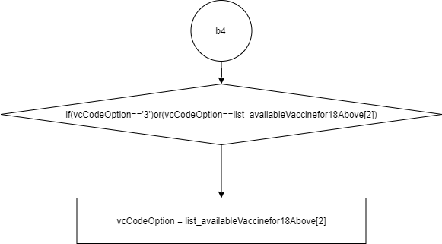

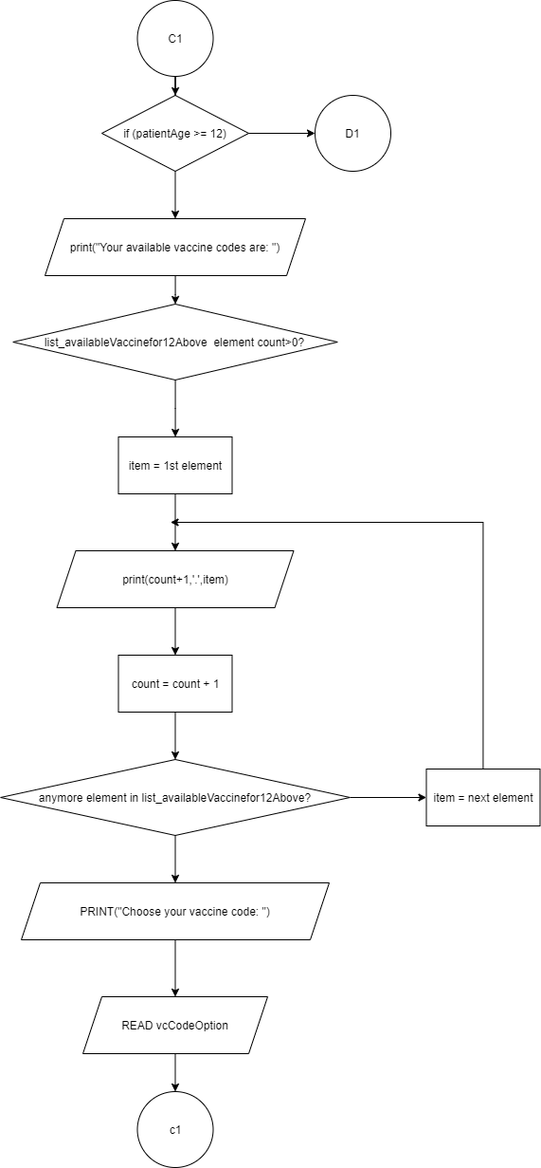

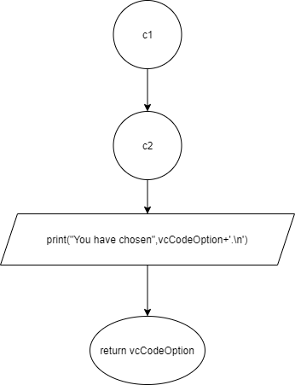

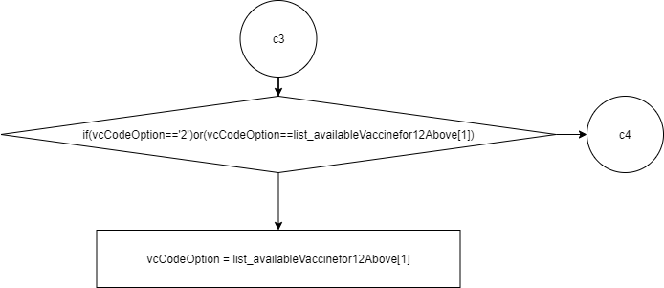

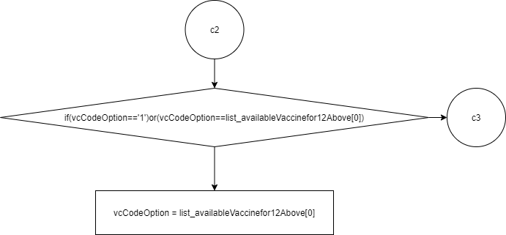

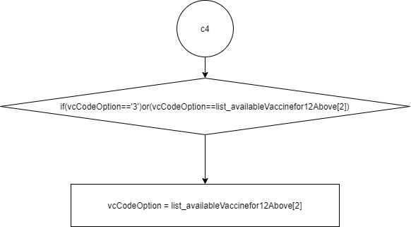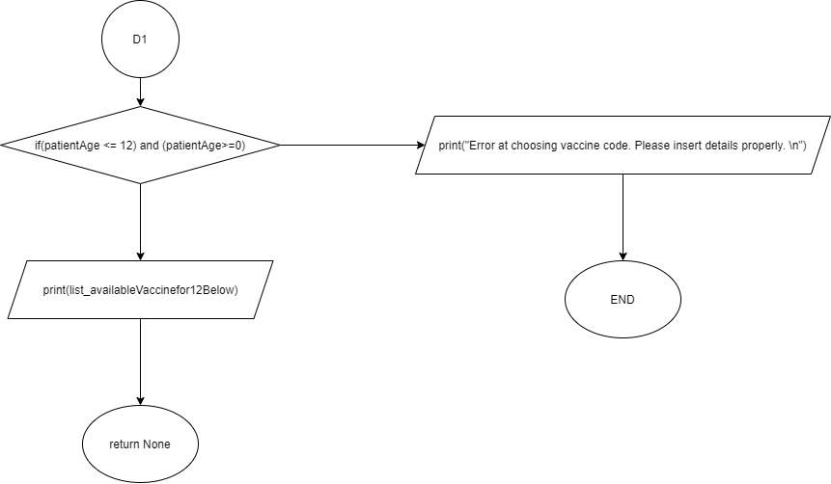

**newPatientRegistration()**

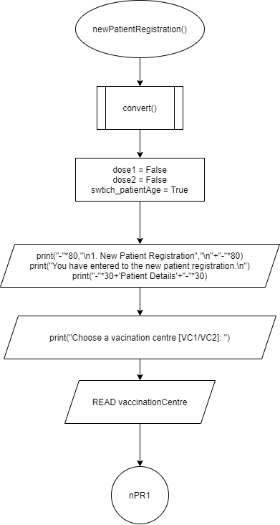

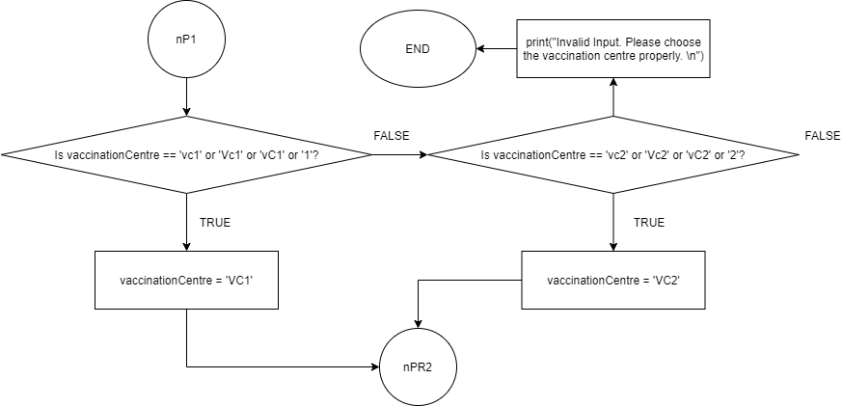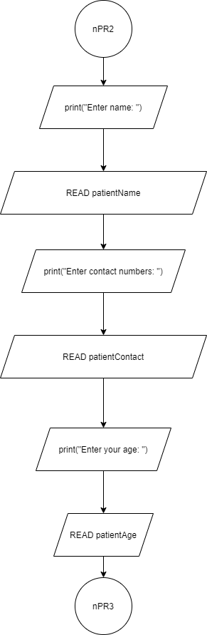

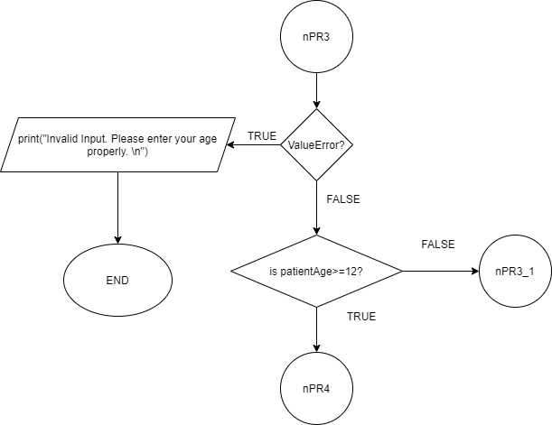

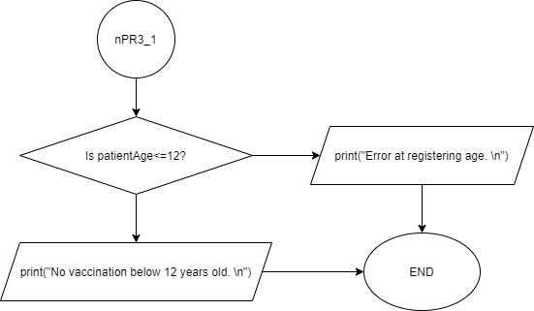

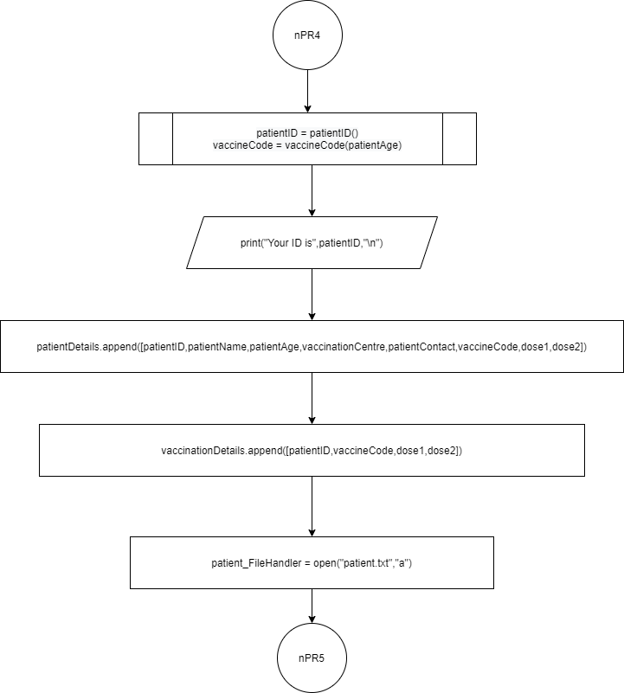

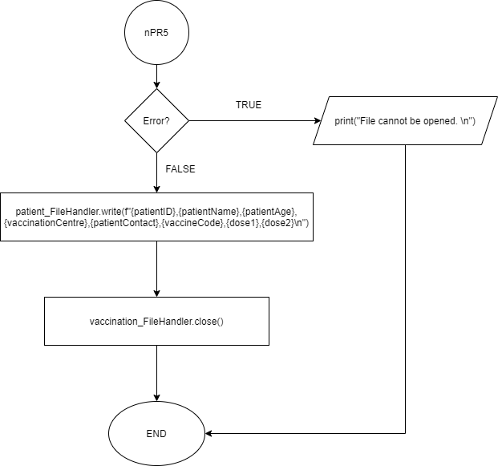

**vacWeekDisplay()**

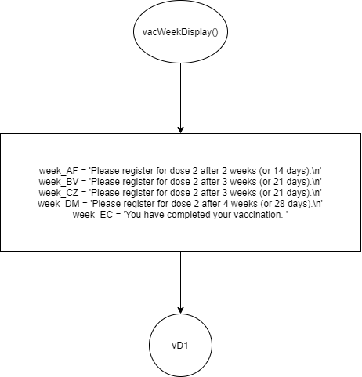

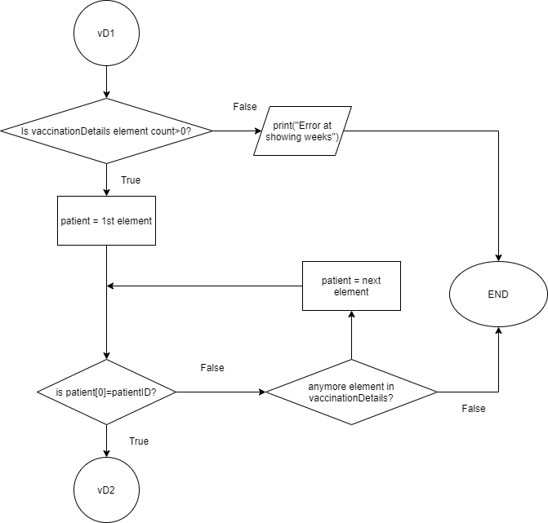

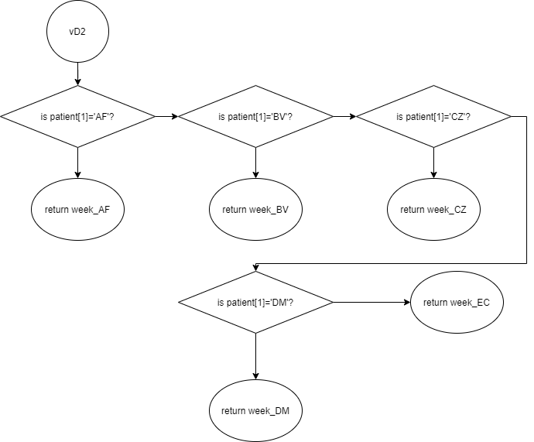

**vaccineAdministration()**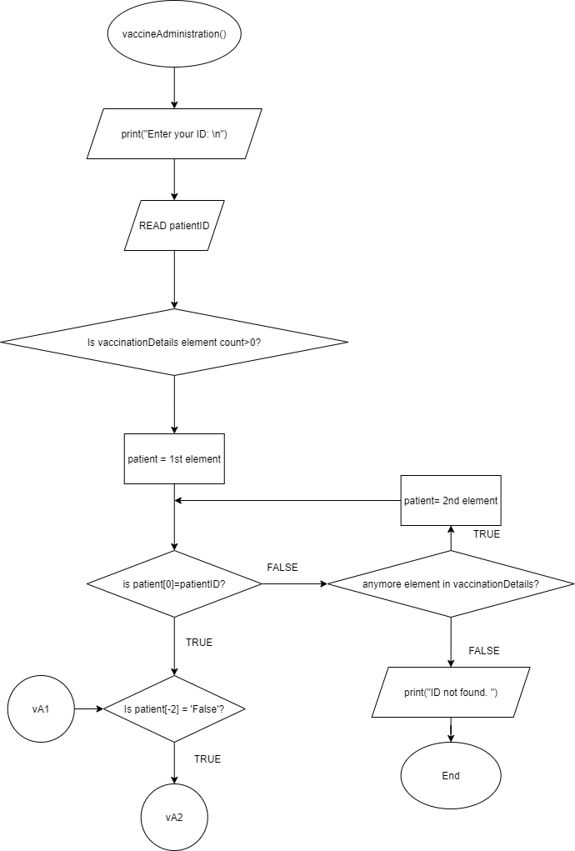

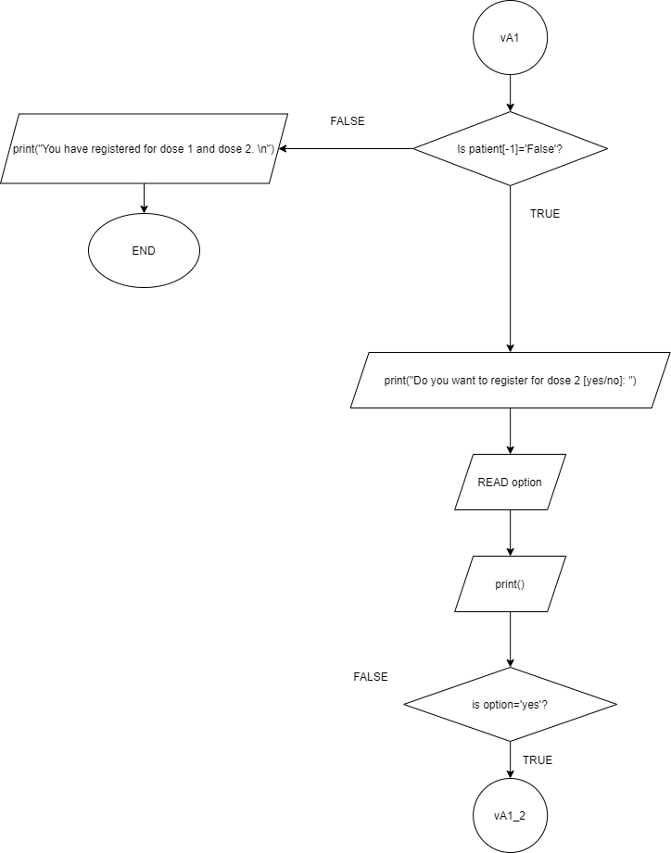

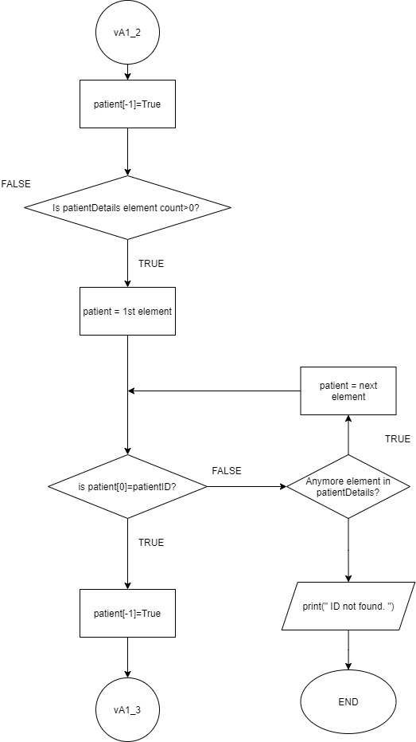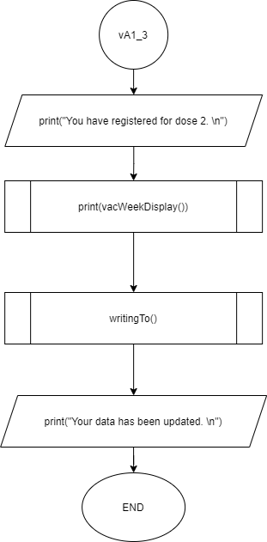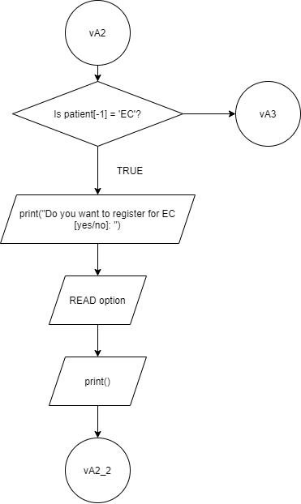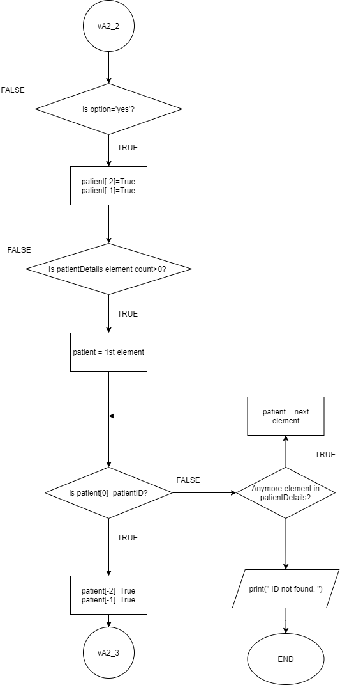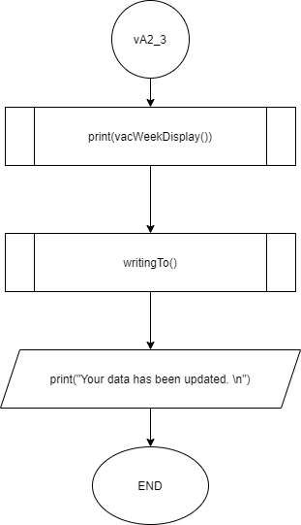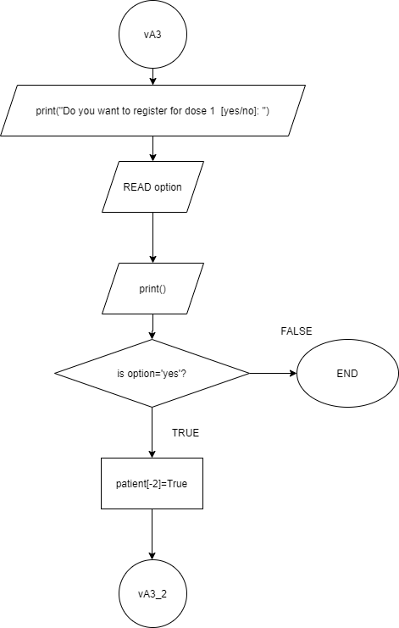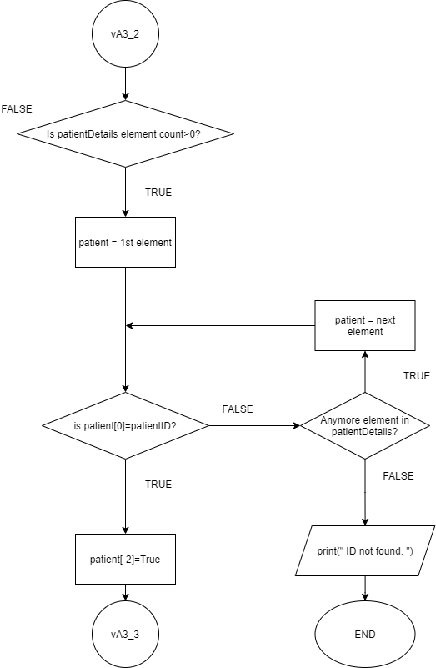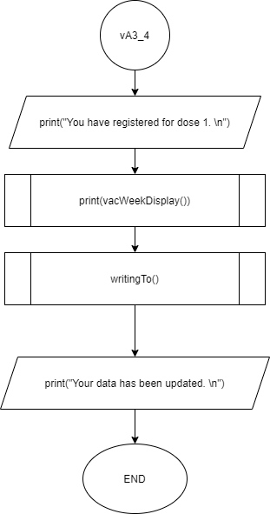

**searchPatientRecordAndVaccinationStatus()**

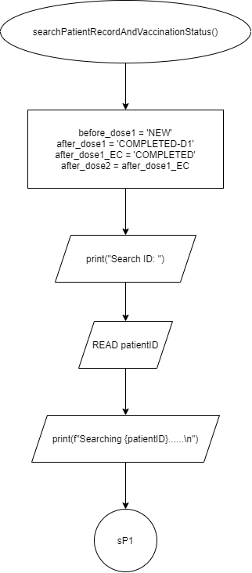

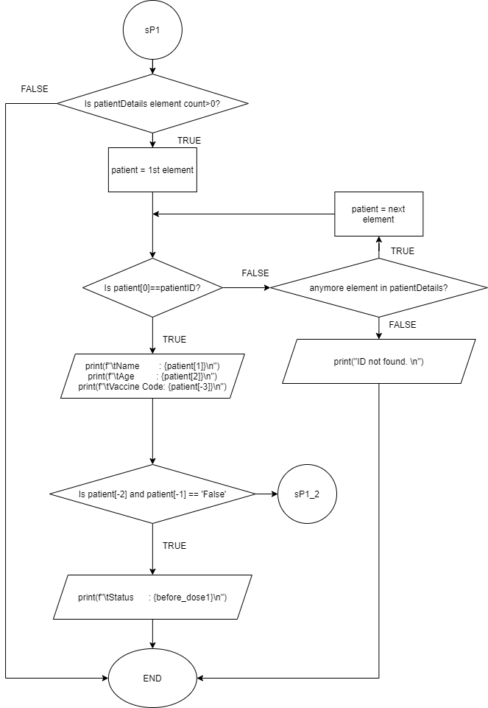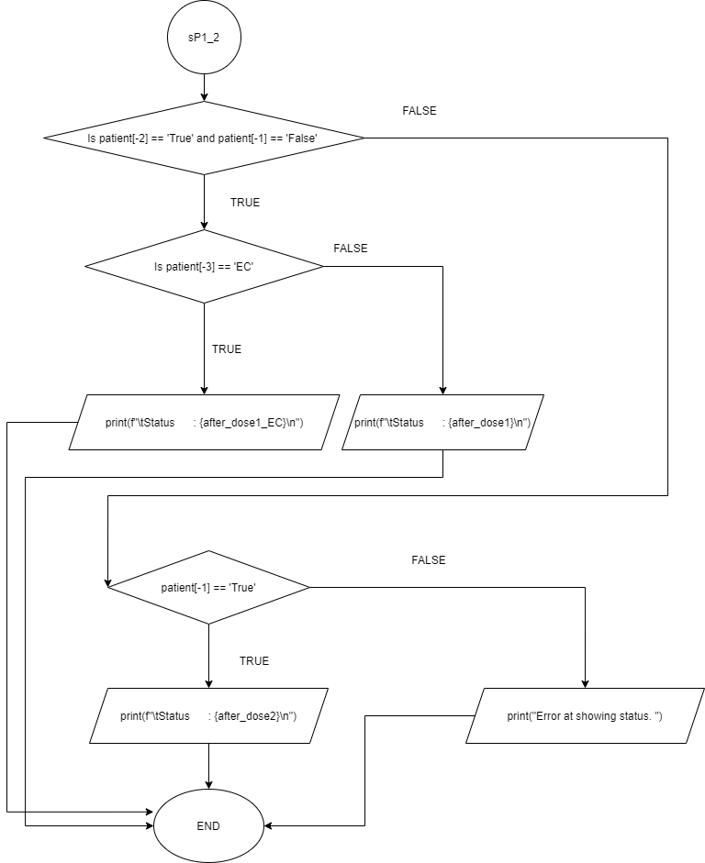

**statisticalInformationOnPatientsVaccinated()**

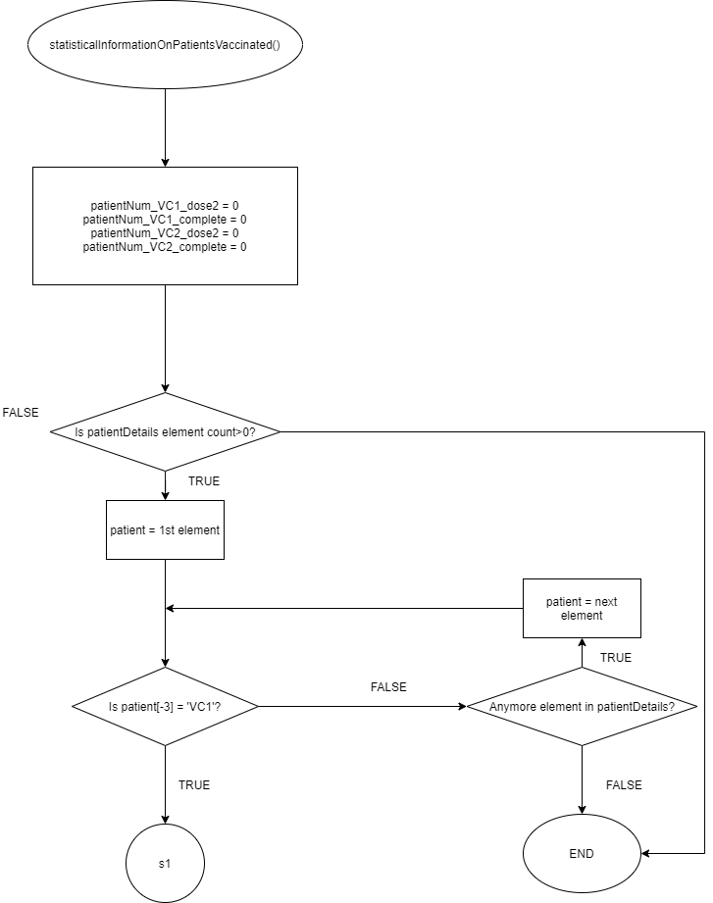

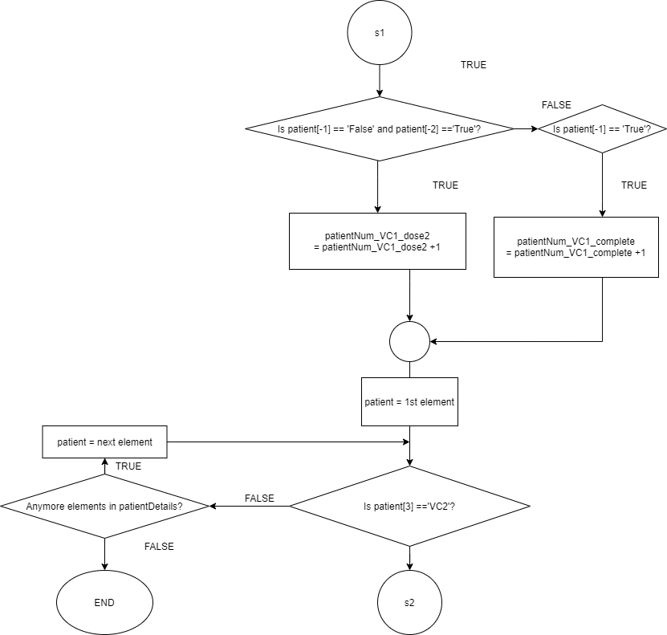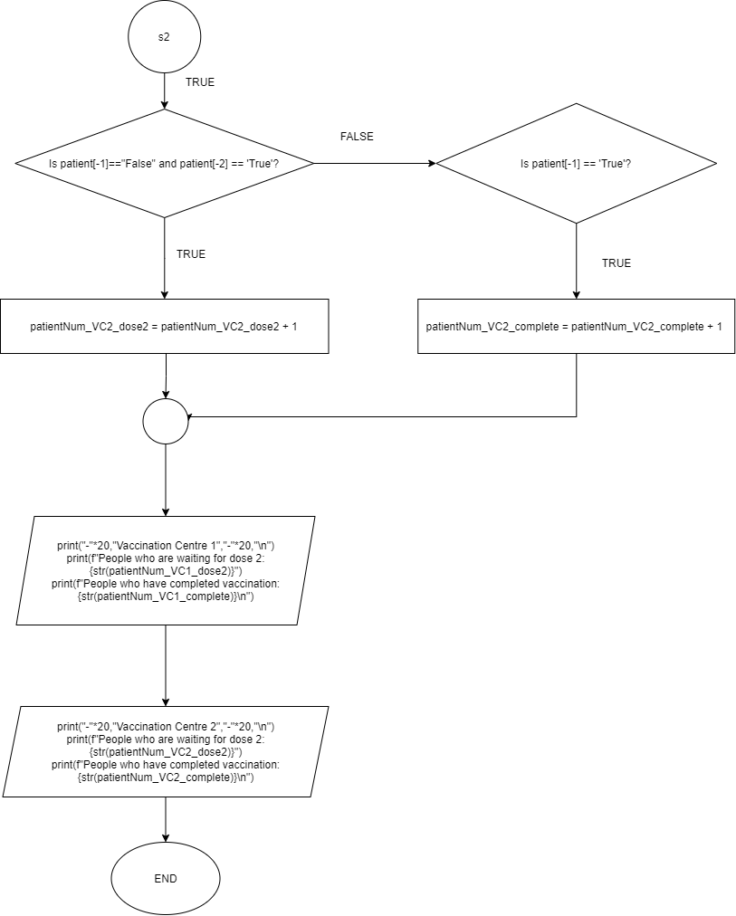

**menu()**

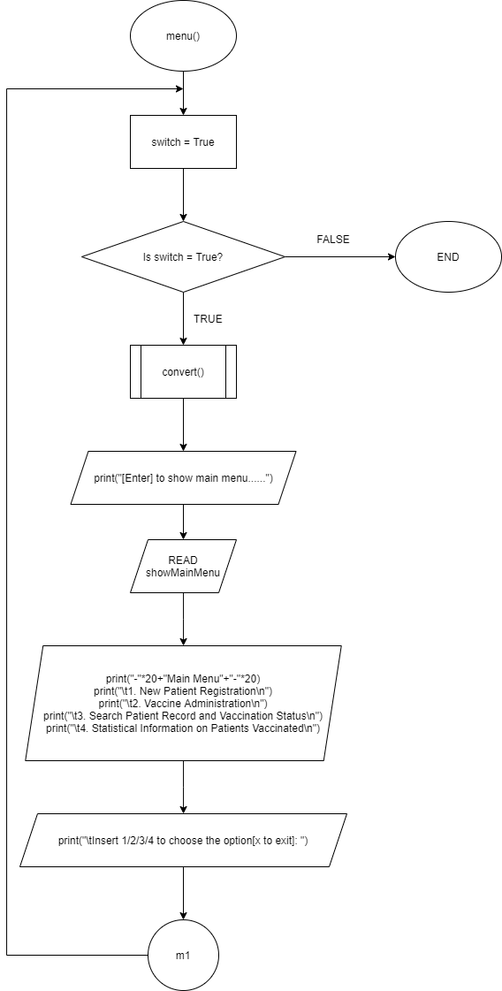

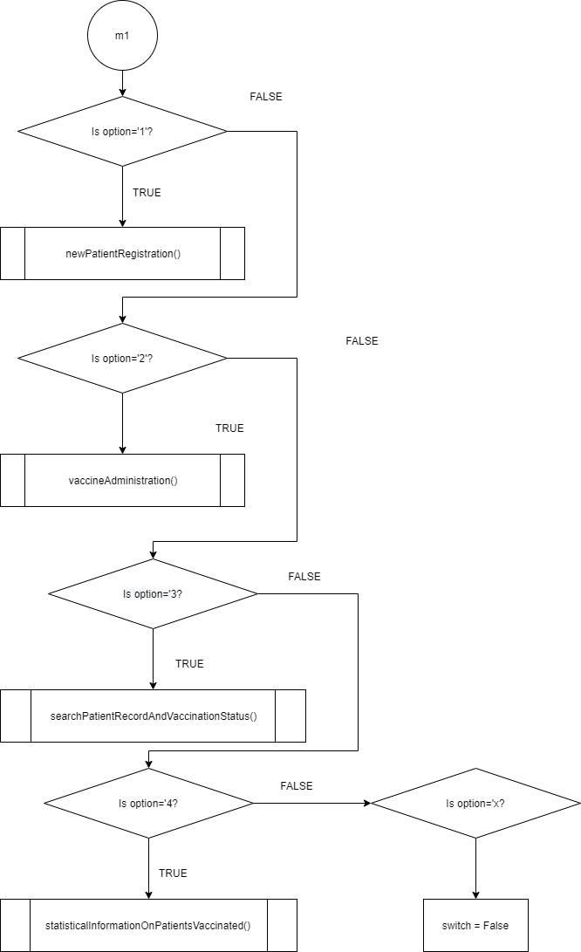

**Program Source Code And Explanation**

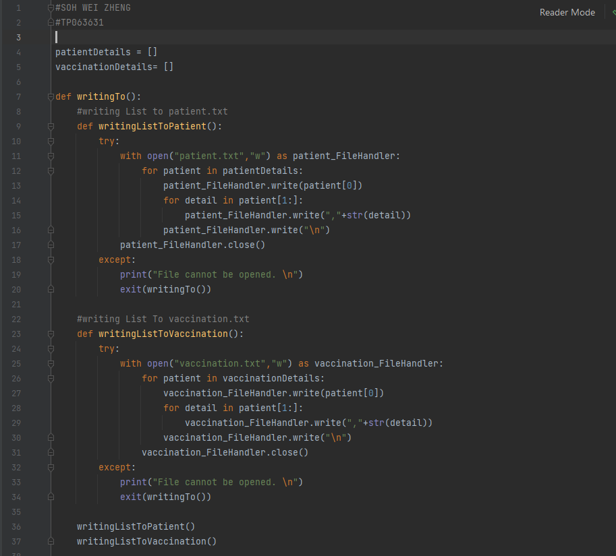

On the 1st line, there is a name “SOH WEI ZHENG” and my TP Number “TP063631”. At line 4 - line 5, I created two lists to store the data which patients insert. The list “patientDetails” stores patients’ IDs, names, ages, chosen vaccination centres, contact numbers, chosen vaccine codes, and the status of dose 1 and dose 2. The list “vaccinationDetails” stores patients’ IDs, chosen vaccine codes, and the status of dose 1 and dose 2.

At line 7 – line 37, I created a function called “writingTo()” which contains 2 functions called “writingListToPatient()” and “writingListToVaccination()”. The writingListToPatient() and the writingListToVaccination() are created to write the data in the list to the “patient.txt” and the “vaccination.txt.” First, the program opens the text file and loops the list. The program writes every first element in the list and joins it with the rest elements. Finally, it will end with a new line and write the next first element in the list. The try and except is used to prevent the program crash when the text file is unopenable. At line 36 – line 37, the writingTo() will call those two functions.

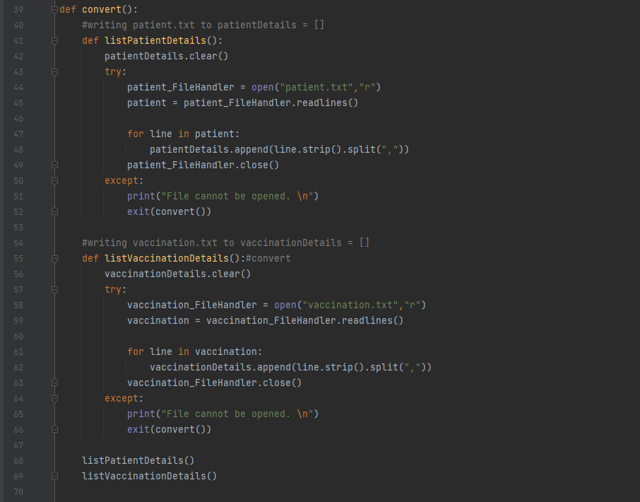

At line 39, the convert() contains 2 functions called “listPatientDetails()” and “listVaccinationDetails()”. Both of them store the data in text files to the patientDetails and vaccinationDetails, First, the function will clear all the elements in the lists, or it will be appended with new data. After that, the program will try to open the text file and read it. Next, the program appends each line with clearing spaces and split each element with “,” to the list. The program will output “File cannot be opened " if the file cannot be opened” instead of crashing the program. At line 68, the convert() function calls those 2 functions.

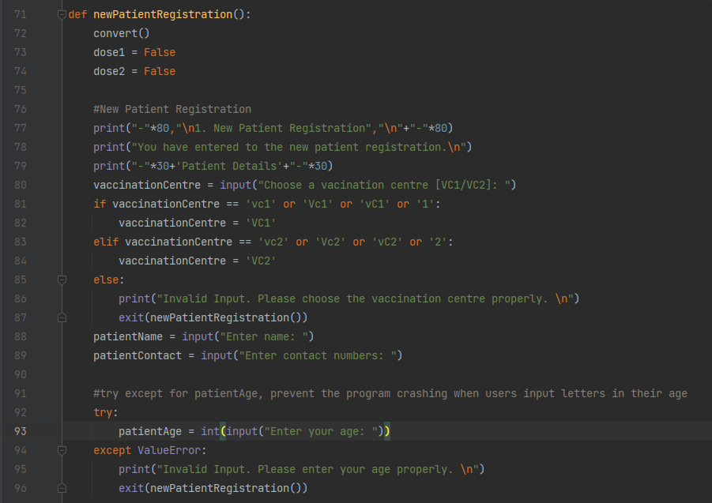

At line 71, a function called “newPatientRegistration()” is created. There are 2 functions called “vaccinCode(patientAge)” and “patientID()” inside the function. In line 72, the function calls convert() function to update the lists for creating ID purposes. First, the function will set the status of dose one and two to ‘False’, which means there are no registered doses. At line 77 – line 79, patients will be informed that they have entered the function and must insert their patient details. At lines 81 – 87, the program will replace the vaccinationCentre that patient chose to a particular string. After that, patients will have to enter their names, contact numbers, and ages. If the patient enters the wrong value in the age, the program will not crash and it will ask the patient to input properly and exit the function.

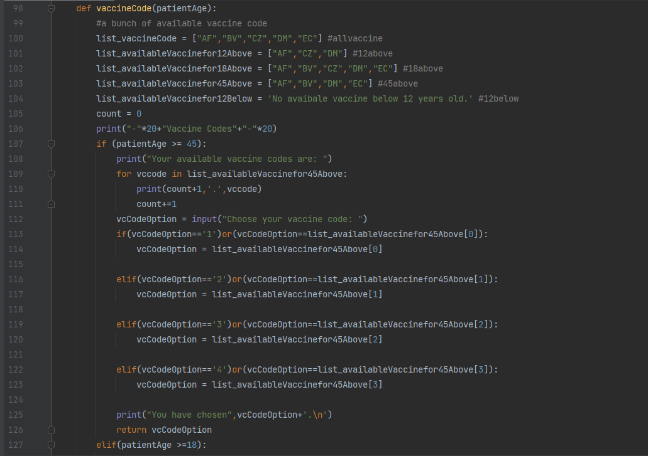

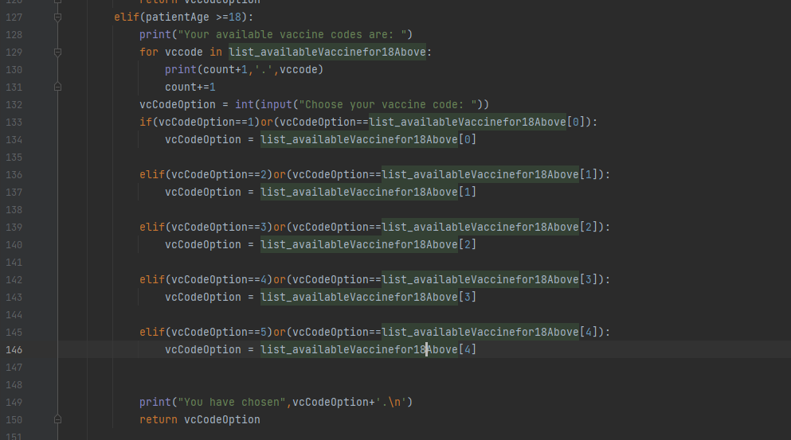

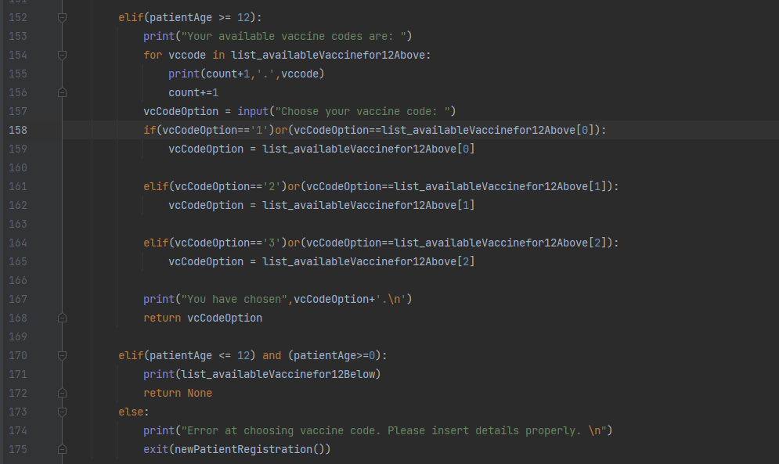

The vaccineCode(patientAge) is called after enter their ages. This function is used to list out the relevant vaccine codes based on their ages. After patients choose their vaccine codes, the function will return their chosen vaccine codes. If the patient’s age is below 12 years old, it will inform the patient that there is no vaccine code. Besides, the ‘else’ will never happen, and if it happens, there is something wrong with the function.

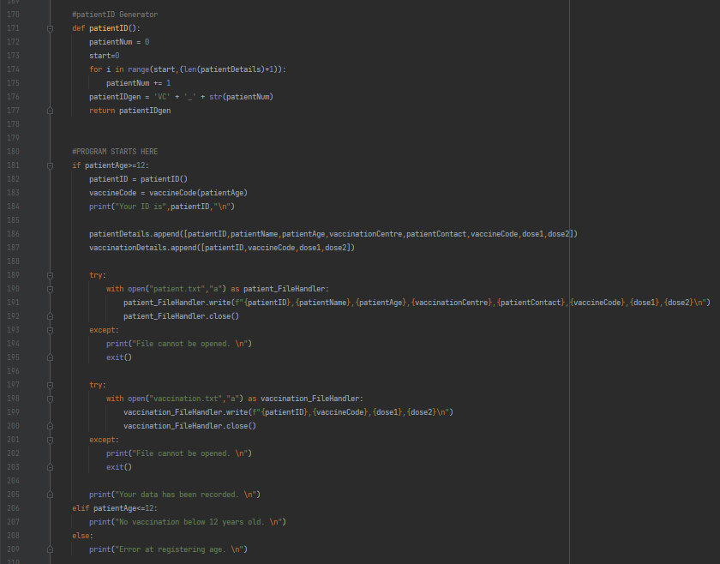

At line 171, the patientID() is created. It creates a sequence patient ID based on the number of elements of the list patientDetails. It will loop the patientDetails and add 1 to patientNum if the range starts from 0 to the number of elements in the list plus one. The patient ID will be created with a format like “VC_1”, “VC_2”, “VC_3”……. and so on. At the end of the function, it will return the patient ID.

Now bring it back to the function newPatientRegistration(), it will keep running if the patientAge is greater than 12 years old. If the patientAge is greater than 12 years old, it will call patientID() and vaccineCode(patientAge). After that, it will show the patients their patient IDs and append all their data to respective lists. Then, the program will try to open the file and write their data into the text file if the file is openable. If there is an error, the program will inform users instead of crashing the program.

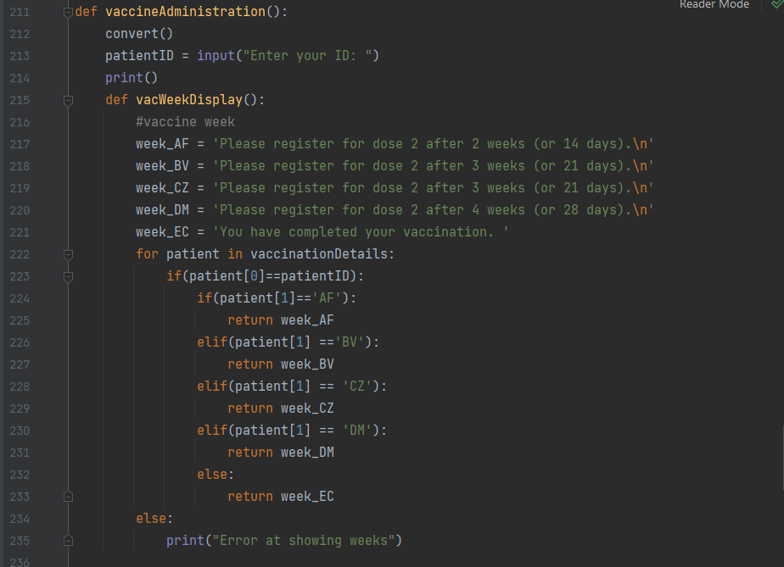

At line 211, the function “vaccineAdministration()” is created. It contains a function called “vacWeekDisplay()” which informs the patients to register for dose two based on their vaccine codes. First, the function calls convert() function to update the list to the latest list for checking vaccine code purposes. Second, the function asks the patient to enter their IDs. Then, the vacWeekDisplay() will be created.

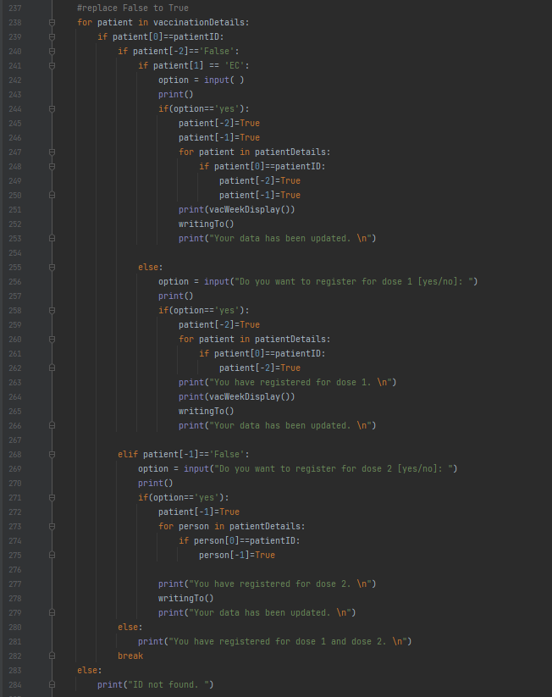

Now bring back to the vaccineAdministration(), the function starts looking for the ID in the list vaccinationDetails and checks if the first element matches the ID entered by users. If an ID matches with the input, it would ask users to confirm the registration. Once they confirm the roster, the function writingTo() will be called to update the data which are stored in text files. If no ID is matched with the input, the program will inform users that their ID has not been found.

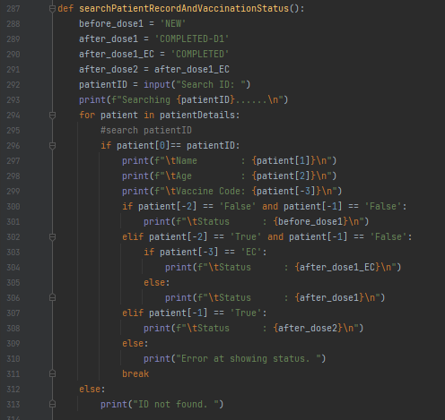

At line 287, a function called searchPatientRecordAndVaccinationStatus() will be created. This function is used to search the patient’s status. First, some strings will be created and the user will be asked to enter their IDs. Then, the function will start searching the patient’s ID. It will loop the list patientDetails and searching for the ID. If there is a matched ID, the function will output the patient’s name, age, vaccine code, and vaccination status. The ‘error at showing status’ should not be happened and if there is no matched ID, the user will be informed.

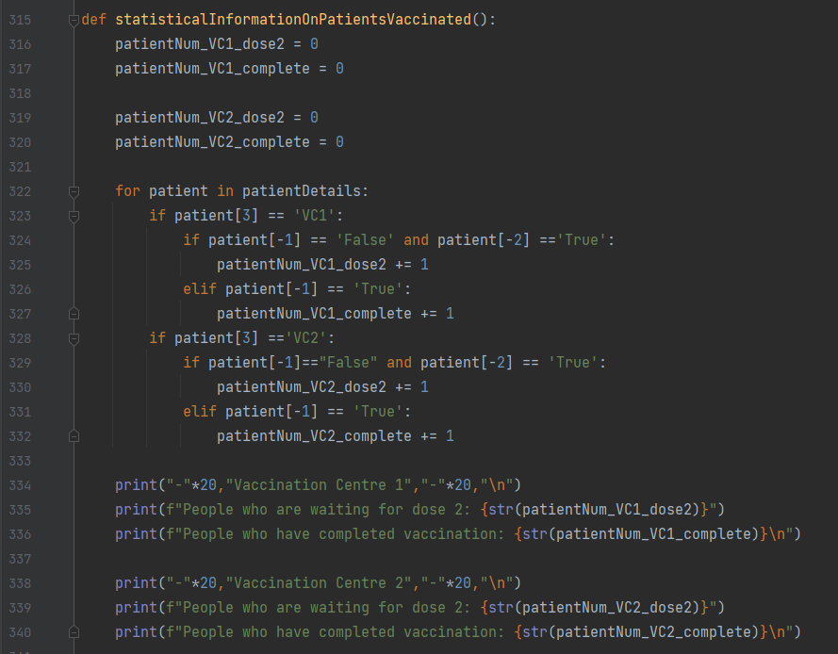

At line 315, the “statisticalInformationOnPatientsVaccinaed()” is created. This function is used to show the statistical information on patients vaccinated. First, the function creates four variables. They are patientNum_VC1_dose2, patientNum_VC1_complete, patientNum_VC2_dose2, and patientNum_VC2_complete. Once the function is called, it will start calculating the number of patients waiting for dose two and the number of patients who have completed vaccination. The function loops the list patientDetails and calculates the patients based on their dose one and two status. If there is a patient match with the requirement, the particular variable will add 1. In the end, the results of those four variables will be shown.

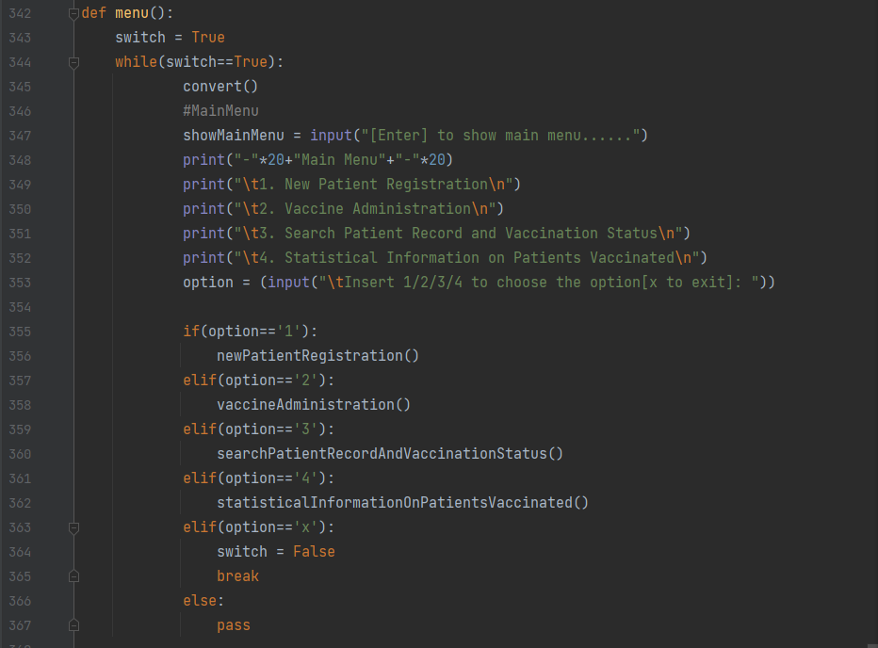

In line 342, I created a function called menu(). This function shows the main menu. First, a Boolean called “switch” will be set to “True”. It is the switch of the whole program, and the program will only run when the switch is True. Then, the program will ask the user to press enter to show the main menu. I created this feature to make the interface more simple. The main menu will only be shown when the enter is pressed.

The menu will show four options. They are new patient registration, vaccine administration, search patient record and vaccination status, statistical information on patients vaccinated. If the user choose the first option, the program will run newPatientRegistration() function; If the user choose the second option, the program will run vaccineAdministration() function; If the user choose the third option, the program will run searchPatientRecordAndVaccinationStatus(); If the user choose the fourth option, the program will run statisticalInformationOnPatientsVaccination() function; If the user enter ‘x’, the program will be terminated.



At the last line, the menu() function will be called to run the program.

**Screenshots Of Sample Input/Output And Explanation**

**Testing New Patient Registration and Vaccine Administration**

Let’s assume I were the user or patient who is totally and going to to register for the patient ID. Once the program has been running, the program requires users to press the enter to show the main menu. I am going to register for my patient ID now so I will choose the first option “1”. After I chose the first option, I have entered the New Patient Registration. First, the program will ask me to choose the vaccination centre, either the centre one or the centre 2. The vaccination centre 1 is nearer to where I live so I would choose the first centre. After that, the program asked for my details such as my name, contact number and the age.

After I entered my age, the program listed out the suitable vaccine codes for me and I would choose the “CZ”. Next, the program will give me the unique patient ID and inform me that my data has been recorded. Meanwhile, my data will be recorded in patient.txt and vaccination.txt. After that, the program will return to the beginning.

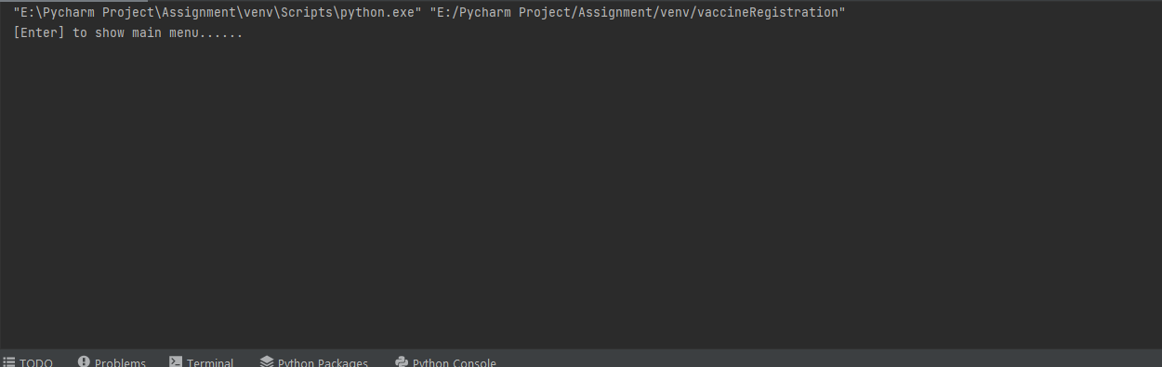

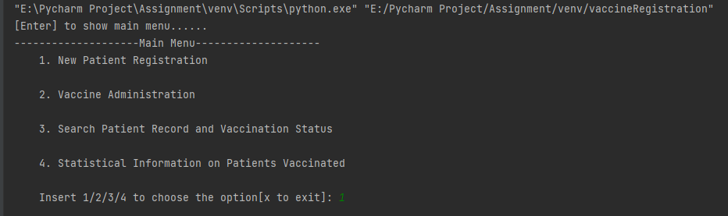

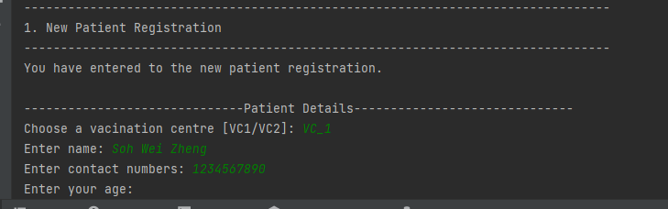

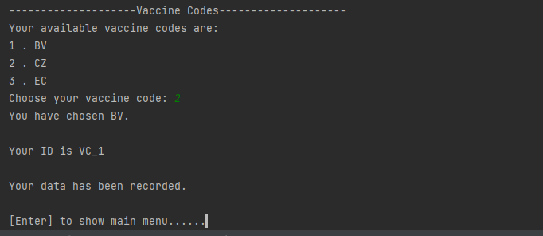

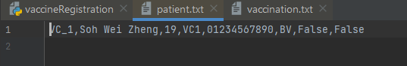

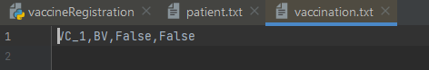

**Testing Vaccine Administration()**

I want to register for my dose 1 so I will press the enter to show the main menu. After that, I will choose the second option which is called Vaccine Administration and the program asked for my patient ID. This time, the program asked me to confirm the registration of dose 1. Once I confirmed the registration, I have registered for my dose 1 and the program will inform me where should I back for the registration of dose 2. Also, the program will inform me that the data has been updated. Meanwhile, as you can see, the data in patient.txt and vaccination.txt has been updated.

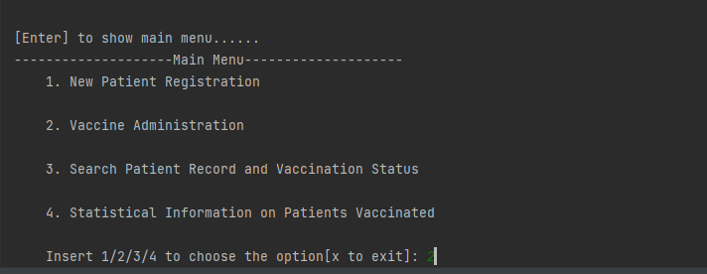

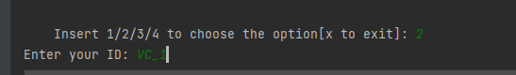

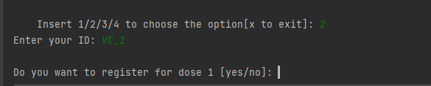

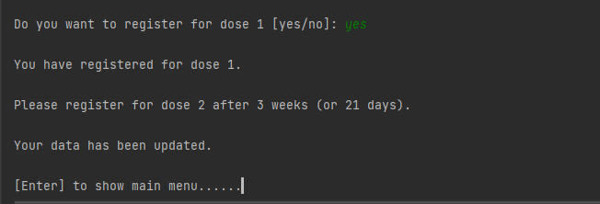

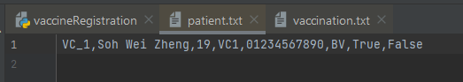

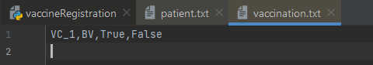

**Testing Search Patient Record and Vaccination Status**

Let’s reset my character and assume that I were the medical staff. I am going to check the status of a patient. I will go for the third option, Search Patient Record and Vaccination Status. Once I have entered the function, it requires me to enter the ID that I want to search. I will search for VC_1. Once I have entered the patient ID, the program will list out the patient’s name, age, vaccine code, and the vaccination status.

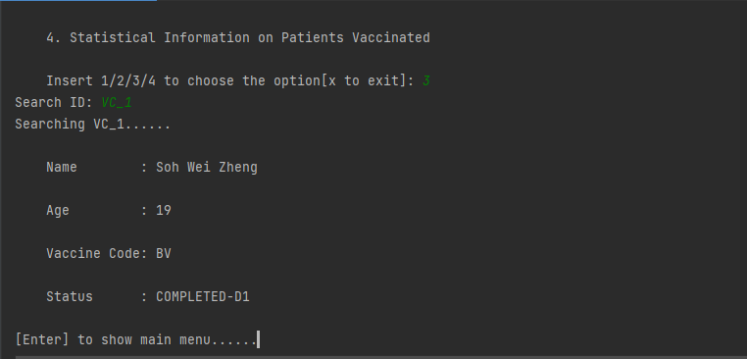

**Testing Statistical Information on Patients Vaccinated**

I just checked the patient’s status and knew the patient has completed for dose 1. Now, I want to know about the statistical information on patients vaccinated so I will go for the fourth option, Statistical Information on Patients Vaccinated. After I selected the fourth option, the program shows me the results.

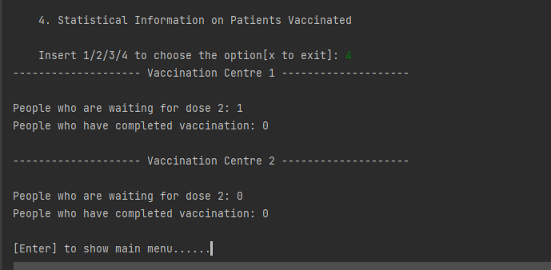

**Testing Invalid Input**

Invalid Input of New Patient Registration

When the patient enters the string in the age, the program will output “Invalid Input. Please enter your age properly”. The program will not crash and the patient’s data will not be stored. There is a feature. If the user enters “1”, the program will recognize it as “VC1”. It makes user more convenient.



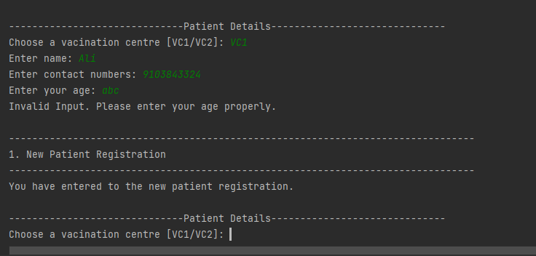

Invalid Input of Vaccine Administration

When the patient enters the ID which is not in the list, the program will print “ID not found.” instead of crashing.

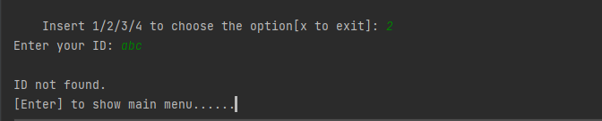

Invalid Input of Search Patient Record And Vaccination Status

When the patient enters the ID which is not in the list, the program will print “ID not found”.

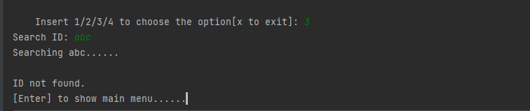

Testing Menu

When the user is not choosing the option, it will not crash the program and the program will ask him for pressing enter again.

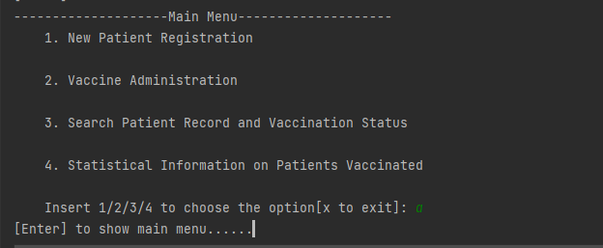

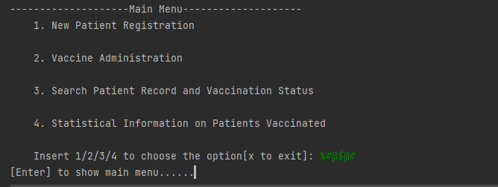

**Testing Terminate Function**

When the patient wants to terminate or stop the program, they can enter “x” to terminate the program.

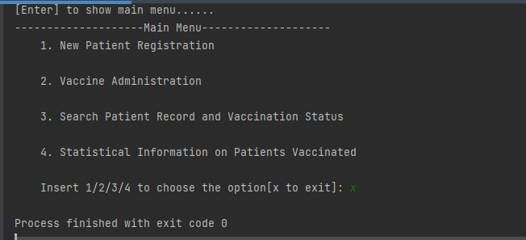

**Testing Register 17 patients**

Testing New Patient Registration

1st Patient

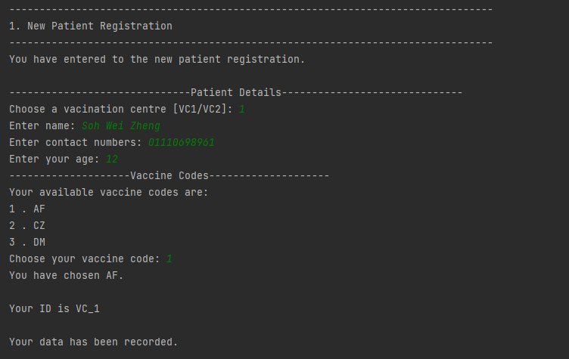

2nd Patient

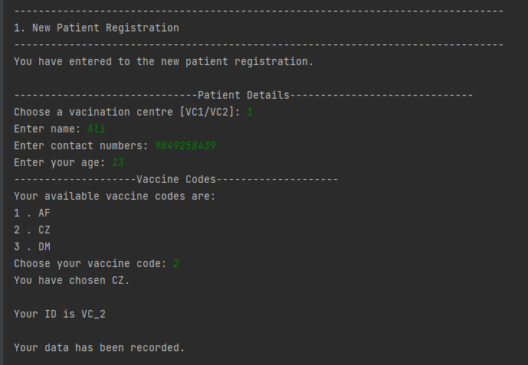

3rd Patient

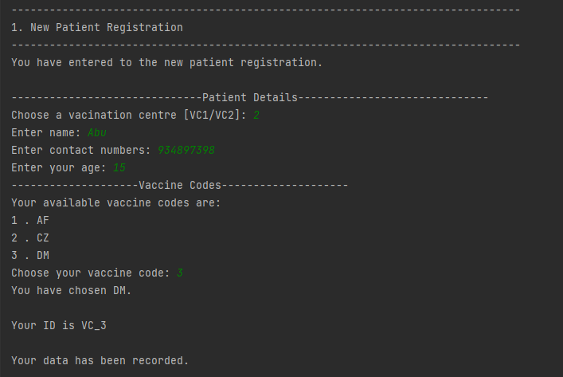

4th Patient

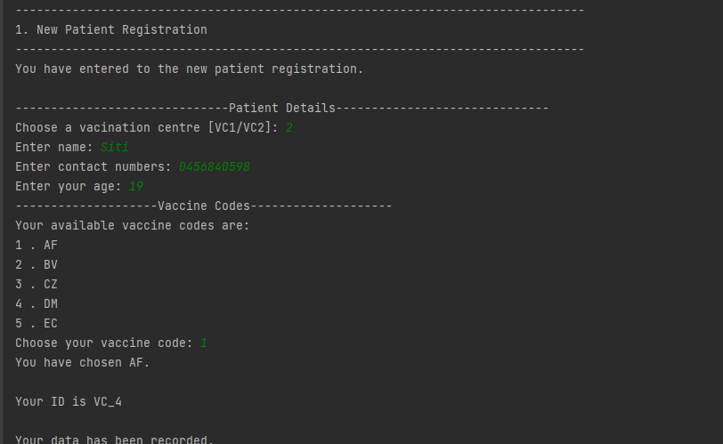

5th Patient

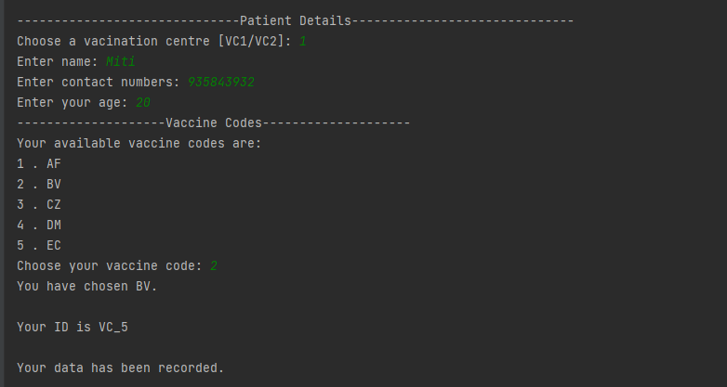

6th Patient

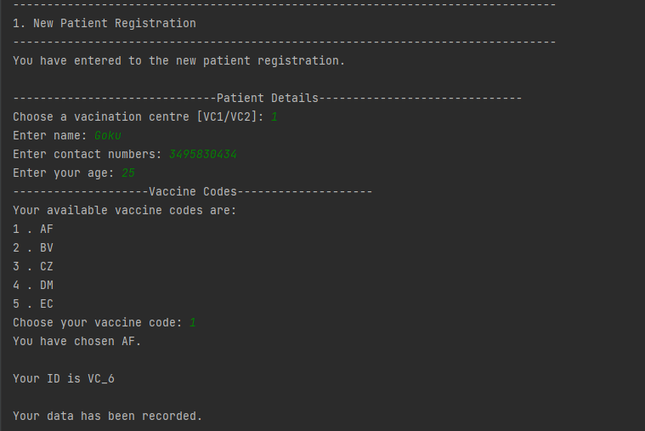

7th Patient

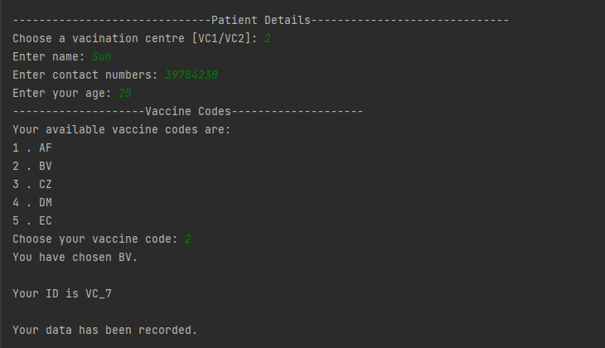

8th Patient

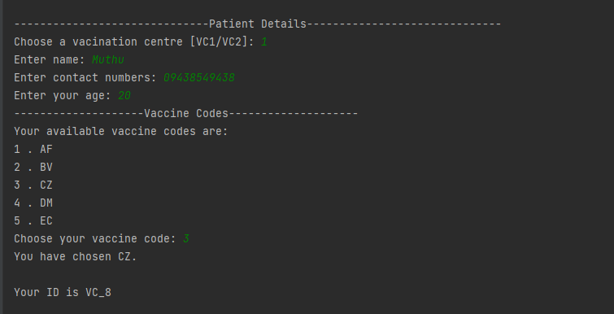

9th Patient

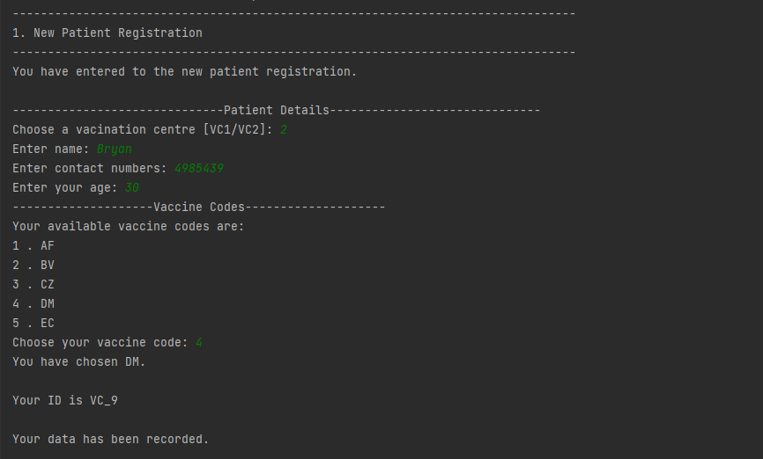

10th Patient

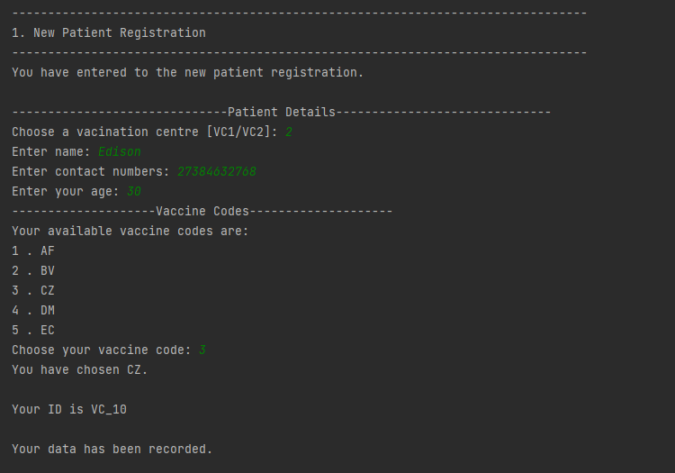

11th Patient

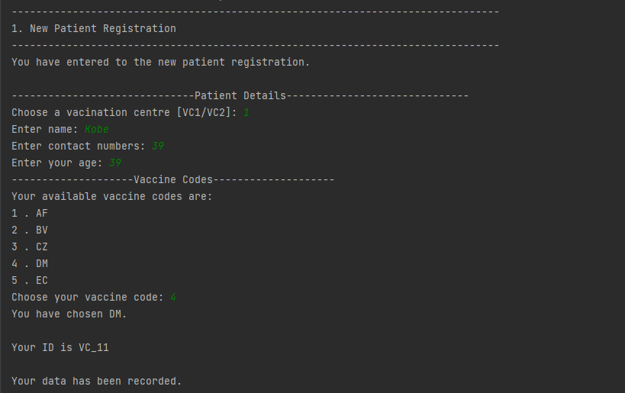

12th Patient

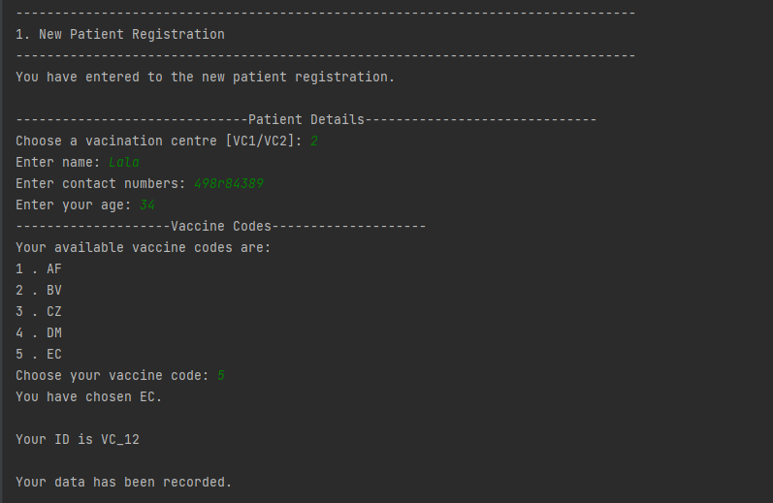

13th Patient

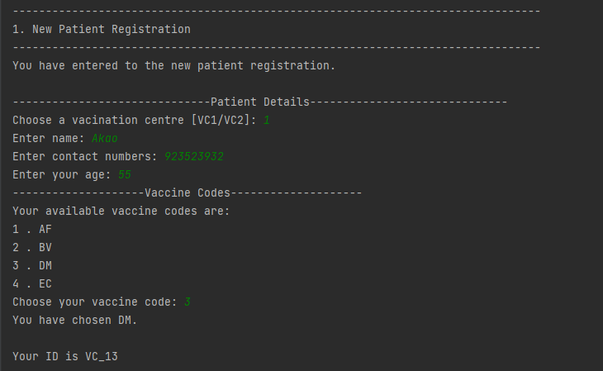

14th Patient

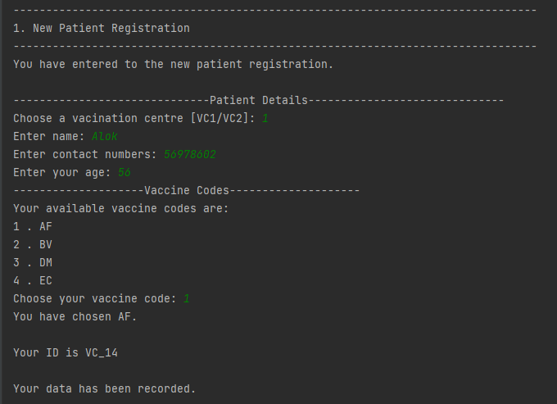

15th Patient

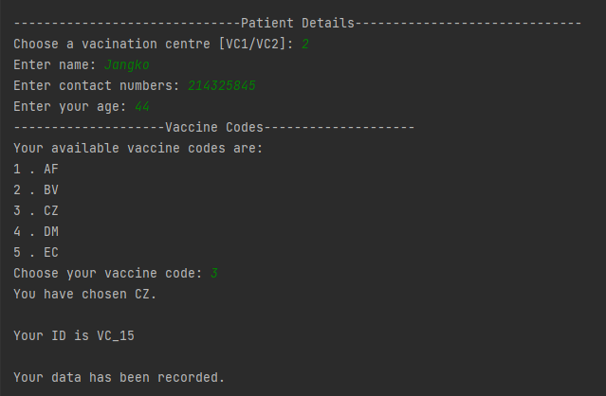

16th Patient

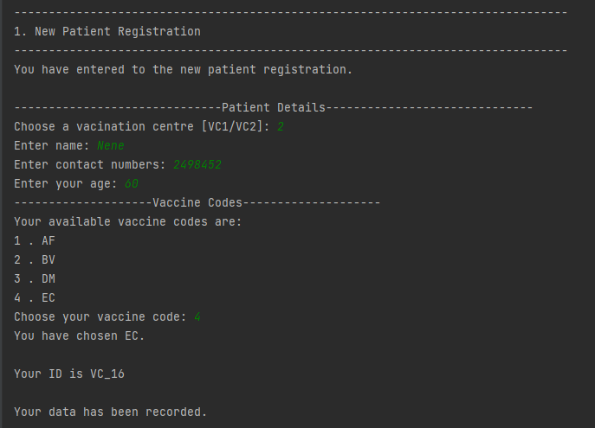

17th Patient

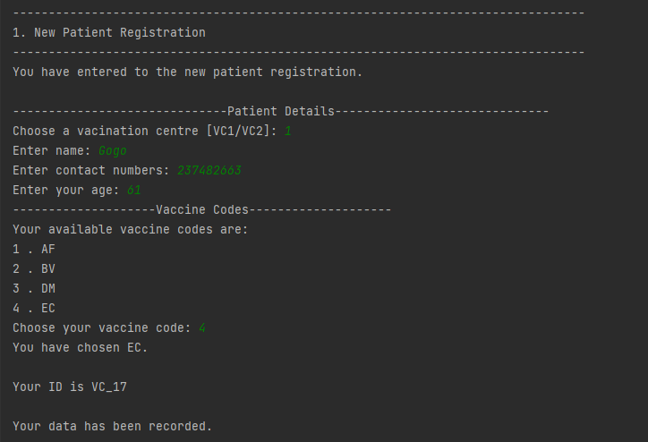

18th Patient

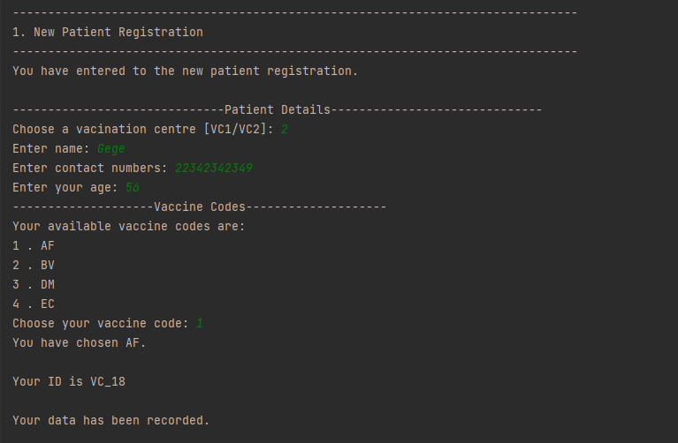

19th Patient

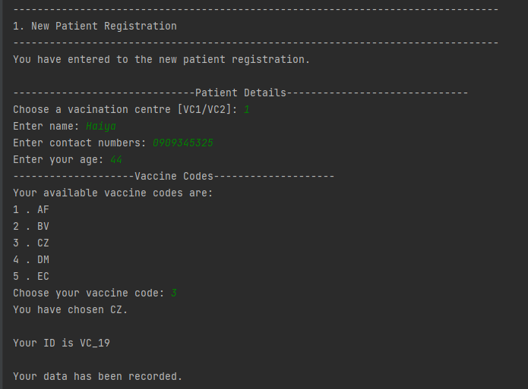

20th Patient

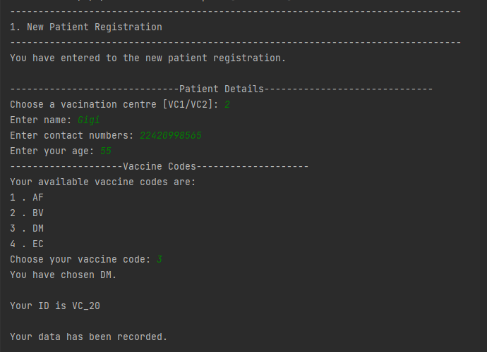

patient.txt

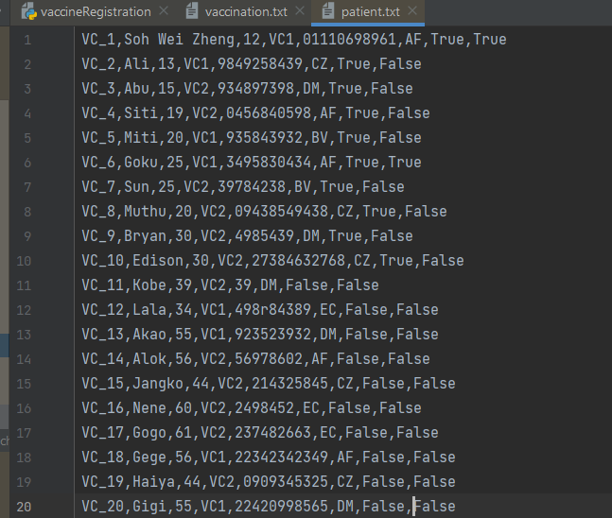

vaccination.txt

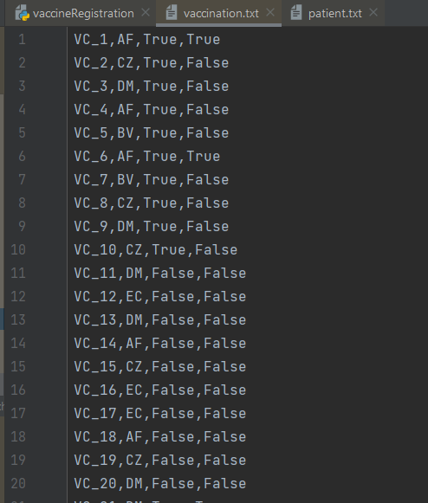

Testing Vaccine Administration

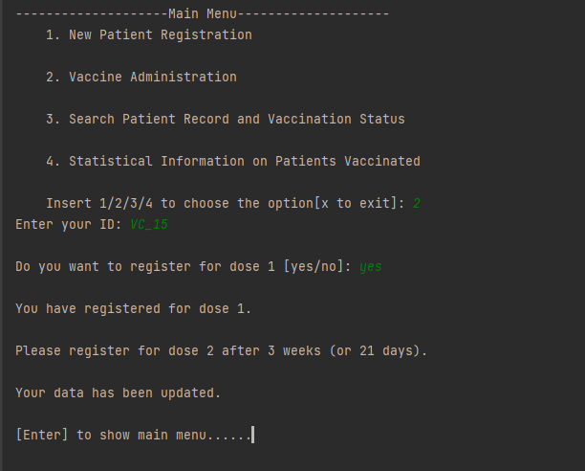

Testing Search Patient Record and Vaccination Status

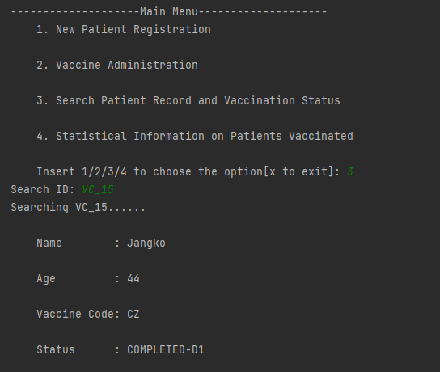

Testing Statistical Information on Patients Vaccinated

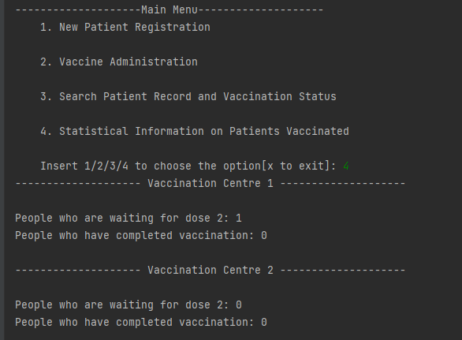

**Conclusion**

In conclusion, the COVID-19 Vaccination Record Management System works fine. Everything inside the program is completed and no buggy. The system allows patient to register for their patient IDs and register for their vaccination. Patients’ data and information will be stored in text files. Besides, users can use the system to search and check a patient’s vaccination status. Moreover, the system also analysis the data and perform the statistical information on patients vaccinated.